Higher Nationals - Summative Assignment Feedback Form

|  |  |  |  |
| --- | --- | --- | --- |
| **Student Name/ID** |  | | |
| **Unit Title** | **Unit 54: Prototyping** | | |
| **Assignment Number** | **1** | **Assessor** |  |
| **Submission Date** |  | **Date Received 1st submission** |  |
| **Re-submission Date** |  | **Date Received 2nd submission** |  |
| **Assessor Feedback:**  **LO1 Explore forms of prototypes appropriate for various functionality and end user testing requirements.**  **Pass, Merit & Distinction P1** **P2** M1              **Descripts**    **LO2. Plan a prototype for specific target end users and planned tests.**  **Pass, Merit & Distinction P3** **P4** **M2** **M3 D1**                      **Descripts**    **LO3. Develop multiple iterations of the prototype using appropriate tools.**  **Pass, Merit & Distinction P5** **P6** **M4** **D2**                  **Descripts**    **LO4. Evaluate user feedback and test results from multiple iterations of the prototype and end user testing.**  **Pass, Merit & Distinction P7** **M5**          **Descripts** | | | |

* Please note that grade decisions are provisional. They are only confirmed once internal and external moderation has taken place and grades decisions have been agreed at the assessment board.

|  |  |  |
| --- | --- | --- |
| **Assessor Feedback:**    *Please note that constructive and useful feedback should allow students to understand:     1. Strengths of performance 2. Limitations of performance 3. Any improvements needed in future assessments.     Feedback should be against the learning outcomes and assessment criteria to help students understand how these inform the process of judging the overall grade.    Feedback should give full guidance to the students on how they have met the learning outcomes and assessment criteria. | | |
| **Grade:** | **Assessor Signature:** | **Date:** |
| **Resubmission Feedback:**  *Please note resubmission feedback is focussed only on the resubmitted work | | |
| **Grade:** **Assessor Signature:** **Date:** | | |
| **Internal Verifier’s Comments:** | | |
| **Signature & Date:** | | |

General Guidelines

1. A Cover page or title page – You should always attach a title page to your assignment. Use the previous page as your cover sheet and make sure all the details are accurately filled.
2. Attach this brief as the first section of your assignment.
3. All the assignments should be prepared using word processing software.
4. All the assignments should be printed on A4-sized papers. Use single-sided printing.
5. Allow 1” for the top, bottom, and right margins and 1.25” for the left margin of each page.

Word Processing Rules

1. The font size should be **12** points and should be in the style of **Time New Roman**.
2. **Use 1.5 line spacing**. Left justify all paragraphs.
3. Ensure that all the headings are consistent in terms of font size and font style.
4. Use the **footer function in the word processor to insert Your Name, Subject, Assignment No, and Page Number on each pag**e. This is useful if individual sheets become detached for any reason.
5. Use word processing applications spell check and grammar check functions to help edit your assignment.

**Important Points:**

1. It is strictly prohibited to use textboxes to add texts to assignments, except for compulsory information. eg: Figures, tables of comparison, etc. Adding text boxes to the body except for the before mentioned compulsory information will result in the rejection of your work.
2. Avoid using page borders in your assignment body.
3. Carefully check the hand-in date and the instructions given in the assignment. Late submissions will not be accepted.
4. Ensure that you give yourself enough time to complete the assignment by the due date.
5. Excuses of any nature will not be accepted for failure to hand in the work on time.
6. You must take responsibility for managing your own time effectively.
7. If you are unable to hand in your assignment on time and have valid reasons such as illness, you may apply (in writing) for an extension.
8. Failure to achieve at least PASS criteria will result in a REFERRAL grade.
9. Non-submission of work without valid reasons will lead to an automatic RE FERRAL. You will then be asked to complete an alternative assignment.
10. If you use other people’s work or ideas in your assignment, reference them properly using the HARVARD referencing system to avoid plagiarism. You have to provide both in-text citations and a reference list.
11. If you are proven to be guilty of plagiarism or any academic misconduct, your grade could be reduced to A REFERRAL, or at worst you could be expelled from the course.

STUDENT ASSESSMENT SUBMISSION AND DECLARATION

When submitting evidence for assessment, each student must sign a declaration confirming that the work is their own.

|  |  |  |  |
| --- | --- | --- | --- |
| Student name: | | Assessor name: | |
| Issue date: | Submission date: | | Submitted on: |
| Programme: | | | |
| Unit: | | | |
| Assignment number and title: | | | |

Plagiarism

Plagiarism is a particular form of cheating. Plagiarism must be avoided at all costs and students who break the rules, however innocently, may be penalised. It is your responsibility to ensure that you understand correct referencing practices. As a university-level student, you are expected to use appropriate references throughout and keep carefully detailed notes of all your sources of materials for material you have used in your work, including any material downloaded from the Internet. Please consult the relevant unit lecturer or your course tutor if you need any further advice.

**Guidelines for incorporating AI-generated content into assignments:**

The use of AI-generated tools to enhance intellectual development is permitted; nevertheless, submitted work must be original. It is not acceptable to pass off AI-generated work as your own.

**Student Declaration**

Student declaration

I certify that the assignment submission is entirely my own work and I fully understand the consequences of plagiarism. I understand that making a false declaration is a form of malpractice.

Student signature: Date:

**Higher National Diploma in Business**

Assignment Brief

|  |  |
| --- | --- |
| Student Name /ID Number |  |
| **Unit Number and Title** | **Unit 54: Prototyping** |
| Academic Year | 2023/24 |
| Unit Tutor |  |
| **Assignment Title** | **Applying concepts and developing a prototype for Travel Buddies** |
| Issue Date |  |
| Submission Date |  |
| IV Name & Date |  |

**Submission format**

The submission should be in the form of an individual written report. This should be written in a concise, formal business style using single spacing and font size 12. You are required to make use of headings, paragraphs and subsections as appropriate, and all work must be supported with research. You must provide in-text citations and the reference list using Harvard referencing system.

**The recommended word count is 4,000–4,500 words excluding annexures. Note that word counts are indicative only and you would not be penalised for exceeding the word count.**

|  |  |
| --- | --- |
|  | |
|  | **Unit Learning Outcomes:** |
|  | LO1. Explore forms of prototypes appropriate for various functionality and end user testing requirements.  LO2. Plan a prototype for specific target end users and plan tests.  LO3. Develop multiple iterations of the prototype using appropriate tools. LO4. Evaluate user feedback and test results from multiple iterations of the prototype and end-user testing. |

|  |  |
| --- | --- |
|  | **Assignment Brief and Guidance:** |

|  |  |
| --- | --- |
|  | **Scenario**  Travel Buddies (Pvt) Ltd is a Courier Management company and -they are planning to expand their business by introducing an online courier management system named TravelBuddies.com. The proposed online courier management system will be fully independent and totally self. The company aims to develop an interactive web-based system that would almost completely automate the essential processes of the courier management system. TravelBuddies (Pvt) Ltd has given the entire project to a leading software development company ThinkLogics (Pvt) Ltd, and you have been assigned to this project by ThinkLogics (Pvt) Ltd.  The various functionalities to be dealt with by the system are classified into different modules.  The proposed software shall have the following modules:  · Booking Module  · Login Module  · Complaint Management Module  · Report Module  · Pickup Module  · Delivery Module  · Maintenance Module  · Consignment tracking module.    The users of this system will include the users, staff, and administrator. The user roles for the proposed system are as follows.  · Registered user  · Guest  · Admin  · Pickup staff  · Delivery staff |



Below table



shows

proposed



functions under each user role for the TravelBuddies.com



.

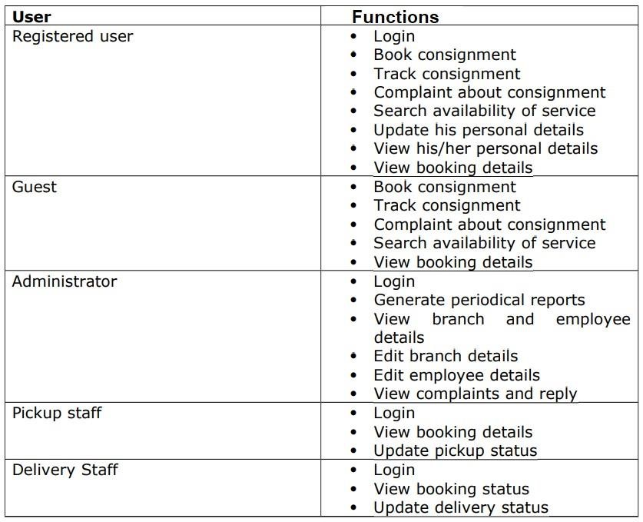

|  |  |
| --- | --- |
|  | **Task 1**   * Discuss specific forms of prototyping use in the software products development and review how these specific prototypes can be used to test the functionalities and end user testing requirements. Your answer should assess a review to the advantages and disadvantages of identified prototyping formats and appropriateness of them to meet different testing outcomes. * Review the standard tools that can be used for prototyping and how they can be used in identifying and testing user requirements effectively in the context of TravelBuddies.com.     **Task 2**   * Review different end user categorization, classification, and behaviour modelling techniques available in prototyping and by applying them select the most appropriate prototyping methodology for the given scenario.      * Examine specific end user from the user population and suggest a suitable prototyping methodology that can be used to test the requirements of the selected user. Provide justification to the selection of the prototyping methodology and produce a plan to test the end user requirement of the selected end user effectively.     **Task 3**     * Explore and employ appropriate prototyping tools and create a prototype according to a plan in order to test the user requirements for the selected end user. * Perform an experiment with the end user and based on the most important feedback, modify the prototype. Build multiple iterations of your prototype by considering the enhancements required in each iteration based on end user feedback until you are satisfied with the final outcome. |
|  | **Task 4**    Review the end-use feedback gathered from the multiple iterations of the prototype and justify the updates given to the final prototype based on both end-user feedback and testing. critically evaluate the overall success of the final prototype you developed when comparing it with the original plan developed to test user requirements. Evaluate the impact of prototyping methodology to effectively meet the objectives of the software development life cycle by taking examples from the prototyping methodology you followed for TravelBuddies.com.  . |

Learning outcomes and Assessment Criteria Table

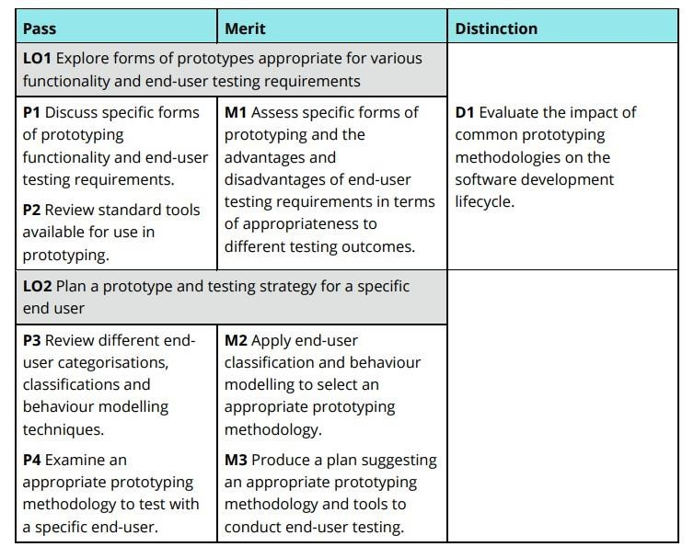

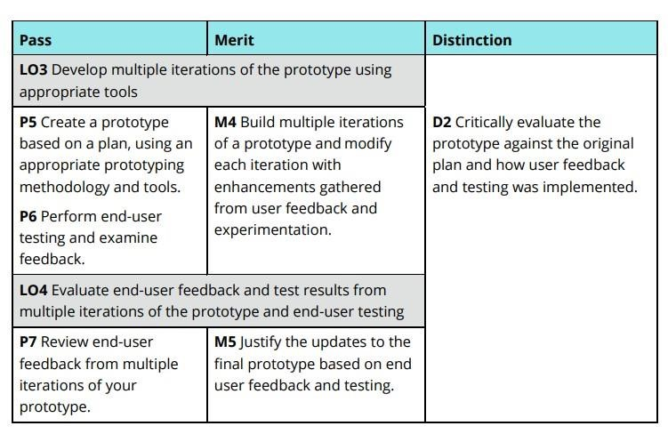

Table of Contents

Activity 01 19

1.1 Introduction of Prototyping 19

Types of Prototyping 19

1.2 Software Prototyping 24

Software Development Life Cycle (SDLC) 24

Types of Prototyping Models 25

1.3 Using Prototypes to Test Functionalities and End-User Testing Requirements 32

Low-Fidelity Prototypes 32

High-fidelity 33

1.4 End-User Testing 35

Benefits of End-User Testing 35

End-User Testing 37

Objectives of End-User Testing 38

1.5 Prototype Tools 39

1.5.1 Hypermedia Management tools 40

1.5.2 Content Management System 42

1.5.3 Interface Builders Tools 44

1.5.4. 4th Generation Systems 46

1.5.5 object-oriented application framework 47

1.6 Tools used for prototyping 48

Activity 02 58

1.6 Introduction of End User 58

1.6.1 Define End-User Categorization and Classification 58

1.6.2 Types of End Users 61

1.7 Define behavior modeling, for prototyping 62

Advantages and disadvantages of behavior modeling 63

Empathy mapping 64

Customer journey mapping 66

1.8 Appropriate prototyping methodology for the given scenario 72

1.9 End user selection for the scenario 74

Activity 03 77

3.1 Discuss the sketching phase of the site 77

3.1.1 Sketches for the provided scenario 79

3.2 WireFrames, explain the phases of the designing 81

3.2.1 Wireframe for the provided scenario 86

3.3 Interface 89

3.4 Conduct a user experiment and collect feedback 92

Activity 04 132

4.1 Analyze overall feedback 132

4.1.1 Overall Analysis on 1st iteration 132

4.1.2 Overall Analysis on 2nd iteration 133

4.1.3 Overall Analysis on 3rd iteration 134

4.2 Define how end-user feedback gathered from the multiple iterations helps the above prototype development overall 135

References 138

**Figure Table**

Figure 12Evolutionary prototyping ................................................................................................................... 20

Figure 23Incremental Prototyping .................................................................................................................... 21

Figure 3Types of Prototyping Models ............................................................................................................... 25

Figure 41.Throwaway Prototyping .................................................................................................................... 26

Figure 52 Evolutionary Prototyping................................................................................................................... 28

Figure 63Incremental Prototyping .................................................................................................................... 30

Figure 7Adobe Xd .............................................................................................................................................. 48

Figure 8 Figma ................................................................................................................................................... 50

Figure 9 UXPin ................................................................................................................................................... 52

Figure 10Vectr ................................................................................................................................................... 54

Figure 11MockFlow ........................................................................................................................................... 56

Figure 12Empathy mapping .............................................................................................................................. 64

Figure 13Customer journey mapping................................................................................................................ 66

Figure 14Experience mapping ........................................................................................................................... 68

Figure 15 Service blueprinting .......................................................................................................................... 70

Figure 16 Sketch ................................................................................................................................................ 77

Figure 17 login sketch ........................................................................................................................................ 79

Figure 18 User sketch ........................................................................................................................................ 79

Figure 19 guest sketch ....................................................................................................................................... 79

Figure 20 Admin sketch ..................................................................................................................................... 80

Figure 21 pickup staff sketch ............................................................................................................................. 80

Figure 22 Delivery Staff ..................................................................................................................................... 80

Figure 23 Wireframes ........................................................................................................................................ 81

Figure 241)Balsamiq .......................................................................................................................................... 83

Figure 25 login wireframe ................................................................................................................................. 86

Figure 26 guest wireframe ................................................................................................................................ 86

Figure 27 user wireframe .................................................................................................................................. 87

Figure 28 Admin wireframe............................................................................................................................... 87

Figure 29pickup staff wireframe ....................................................................................................................... 88

Figure 30 Login Interface .................................................................................................................................. 89

Figure 31 Guest Interface .................................................................................................................................. 89

Figure 32 Admin Interface ................................................................................................................................. 90

Figure 33 Pickup Staff Interface......................................................................................................................... 90

Figure 34 Registered user Interface .................................................................................................................. 91

Figure 35 Delivery staff Interface ...................................................................................................................... 91

Figure 36 Interface (1st Iteration) 01 ................................................................................................................ 92

Figure 37Interface (1st Iteration) 02 ................................................................................................................. 93

Figure 38 Interface (1st Iteration) 03 ................................................................................................................ 93

Figure 39 Interface (1st Iteration) 04 ................................................................................................................ 94

Figure 40 Interface (1st Iteration) 05 ................................................................................................................ 94

Figure 41 Interface (1st Iteration) 06 ................................................................................................................ 95

Figure 42 Feedback analysis (1st Iteration) ..................................................................................................... 102

Figure 43 Feedback analysis (1st Iteration) 02 ................................................................................................ 103

Figure 44 Feedback analysis (1st Iteration) 03 ................................................................................................ 104

Figure 45 Feedback analysis (1st Iteration) 05 ................................................................................................ 105

Figure 46 Feedback analysis (1st Iteration) 05 ................................................................................................ 106 Figure 47 Feedback analysis (1st Iteration) 06 ................................................................................................ 107

Figure 48 Interface (2nd Iteration) 01 ............................................................................................................. 108

Figure 49 Interface (2nd Iteration) 02 ............................................................................................................. 108

Figure 50 Interface (2nd Iteration) 03 ............................................................................................................. 109

Figure 51 Interface (2nd Iteration) 04 ............................................................................................................. 109

Figure 52 Interface (2nd Iteration) 05 ............................................................................................................. 110

Figure 53 Interface (2nd Iteration) 06 ............................................................................................................. 110

Figure 54 Feedback Analysis (2nd Iteration) 01 .............................................................................................. 115

Figure 55 Feedback Analysis (2nd Iteration) 02 .............................................................................................. 116

Figure 56 Feedback Analysis (2nd Iteration) 03 .............................................................................................. 117

Figure 57 Feedback Analysis (2nd Iteration) 04 .............................................................................................. 118

Figure 58 Feedback Analysis (2nd Iteration) 05 .............................................................................................. 119

Figure 59 Feedback Analysis (2nd Iteration) 06 .............................................................................................. 120

Figure 60 Interface (3rd Iteration) 01 .............................................................................................................. 121

Figure 61 Interface (3rd Iteration) 02 .............................................................................................................. 121

Figure 62 Interface (3rd Iteration) 03 .............................................................................................................. 122

Figure 63 Interface (3rd Iteration) 04 .............................................................................................................. 122

Figure 64 Interface (3rd Iteration)05 ............................................................................................................... 123

Figure 65 Interface (3rd Iteration) 06 .............................................................................................................. 123

Figure 66 Feedback Analysis (3rd Iteration) 01 ............................................................................................... 126

Figure 67 Feedback Analysis (3rd Iteration) 02 ............................................................................................... 127

Figure 68 Feedback Analysis (3rd Iteration) 03 ............................................................................................... 128

Figure 69 Feedback Analysis (3rd Iteration) 04 ............................................................................................... 129

Figure 70 Feedback Analysis (3rd Iteration) 05 ............................................................................................... 130

Figure 71 Feedback Analysis (3rd Iteration) 06 ............................................................................................... 131

Figure 72 4.1.1Overall Analysis on 1st iteration .............................................................................................. 132

Figure 73 Overall Analysis on 2nd iteration .................................................................................................... 133

Figure 74 4.1.3Overall Analysis on 3rd iteration ............................................................................................. 134

**Table**

Table 14.Extreme Prototyping ........................................................................................................................... 22

Table 2Advantages and Disadvantages of Throwaway Prototyping .................................................................. 27

Table 3Advantages and Disadvantages of Evolutionary Prototyping ................................................................ 29

Table 4Advantages and Disadvantages Incremental Prototyping ..................................................................... 31

Table 5Advantages and Disadvantages Low-Fidelity Prototypes ...................................................................... 32

Table 6Advantages and Disadvantages of High-fidelity .................................................................................... 33

Table 7Advantages and Disadvantages Beta Versions ....................................................................................... 34

Table 8Advantages and Disadvantages of Hypermedia Management tools ..................................................... 41

Table 9Advantages and Disadvantages of Content Management System ........................................................ 43

Table 10Advantages and Disadvantages of Adobe XD ...................................................................................... 49

Table 11Advantages and Disadvantages of Figma ............................................................................................ 51

Table 12Advantages and Disadvantages of UXPin ............................................................................................ 53

Table 13Advantages and Disadvantages of Vectr .............................................................................................. 55

Table 14Advantages of Disadvantages of Mockflow ......................................................................................... 57

Table 15 Advantages and disadvantages of behavior modeling ....................................................................... 63

Table 16Advantages and Disadvantages of Sketch ............................................................................................ 78

Table 17Advantages and Disadvantages of Wireframe ..................................................................................... 82

# Activity 01

# 1.1 Introduction of Prototyping

A prototype is an early sample, model or release of a product created to test a concept or process. Typically, a prototype is used to evaluate a new design to improve the accuracy of analysts and system users. It is the step between the formalization and the evaluation of an idea.

Prototypes are a crucial part of the design process and a practice used in all design disciplines. From architects, engineers, industrial designers and even service designers, they make their prototypes to test their designs before investing in their mass production. (Ramirez, 2018)

### Types of prototyping

##### 1. Rapid (Throwaway) prototyping

Rapid prototyping is also known as “throwaway prototyping” because the prototype is expected to be relevant only in the short term, such as one sprint in the Agile development framework. It may go through several cycles of feedback, modification, and evaluation during that time. When all the stakeholders are satisfied, it becomes a reference for the designers and developers to use. After the sprint is completed, the prototype is discarded and a new one is built for the next sprint.

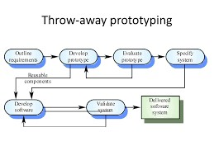

Throwaway prototyping can be applied to less-than-rapid prototypes as well. Paper prototypes, in which the designs are simulated on pieces of paper or cardboard, are by definition “throwaway.” Computer files, whether static images or interactive prototypes, will end up on someone’s hard drive for eternities even though they are almost never needed after the development cycle. (AndPlus, 2020)

##### 2. Evolutionary prototyping

An evolutionary prototype differs from the traditional notion of a software prototype; an evolutionary prototype is a functional piece of software, not just a simulation. Evolutionary prototyping starts with a product that meets only the system requirements that are understood. It won’t do everything the customer requires, but it makes a good starting point. New features and functions can be added as those requirements become clear to the stakeholders. That’s the “evolutionary” nature of this prototype. (AndPlus, 2020)

In a way, the first iteration of an evolutionary prototype is similar to the minimum viable product (MVP), or software that has the absolute minimum functionality to make it useful. The distinction lies in how the requirements for that first version are selected.

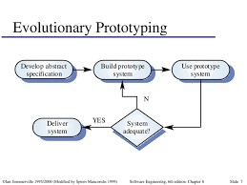

*Figure 12Evolutionary prototyping*

Purpose: Develop a robust prototype that evolves over time based on user feedback.

Process: Build an initial version of the system, gather feedback, and continuously improve the prototype until it becomes the final product.

Use Case: Suitable for complex systems where requirements are not fully understood from the beginning.

##### 3. Incremental Prototyping

Incremental prototyping is useful for enterprise software that has many modules and components which may be loosely related to one another. In incremental prototyping, separate small prototypes are built in parallel. The individual prototypes are evaluated and refined separately, and then merged into a comprehensive whole, which can then be evaluated for consistency in look, feel, behavior, and terminology. The concern with incremental development is that the appearance and feel of the prototypes might change so significantly that the modules feel like whole distinct pieces of software. To achieve consistency, the design team should establish certain guiding principles ahead of time and put the designers on a short leash.. (AndPlus, 2020)

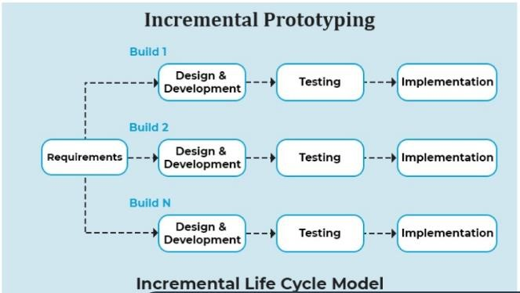

*Figure 23Incremental Prototyping*

Purpose: Develop a system in small, manageable segments or increments.

Process: Divide the system into smaller parts, build a prototype for each part, and integrate them as they are developed.

Use Case: Effective for large projects, allowing for parallel development and testing of different components.

##### 4. Extreme Prototyping

Extreme prototyping is more common for web application development. Web applications are composed of

|  |  |
| --- | --- |
| **Presentation layer** | **Services layer** |
| 1) Displayed in the user’s browser | 1. Communications services 2. Business logic 3. Authentication and authorization 4. Other back-end services |

*Table 14. Extreme Prototyping*

Extreme prototyping is conducted in three phases:

1. Build HTML wireframes to simulate the presentation layer. These web pages have limited interactivity. They are complete enough to show users the various user journeys through the application.
2. Transform the wireframes to fully functional HTML pages, tying them to a simulated services layer.
3. Code and implement the services layer.

With this approach, the user interface is designed and developed before any of the underlying technology is implemented, which is what gives it the “extreme” tag. The services developers then make the whole thing work.

Purpose: Specifically used for web development, focusing on iterative design and user feedback.

Process:

1. Create a static version of the website with basic functionality.
2. Implement functional screens and services.
3. Integrate all services into the final prototype.

Use Case: Ideal for web applications where rapid iterations and user feedback are crucial.

##### Characteristics of prototyping

Prototyping is characterized by its iterative nature, where multiple versions of a product or system are developed and refined based on feedback and testing. This iterative development allows designers and developers to progressively enhance the prototype's features, usability, and performance. Prototypes serve as tangible representations of ideas or concepts, bridging the gap between abstract concepts and concrete solutions. They range from low-fidelity models, such as sketches or simple mock-ups, to high-fidelity prototypes that closely resemble the final product in functionality and appearance. This flexibility enables teams to explore different design options and validate assumptions early in the development cycle. Prototyping is a user-centered design process that prioritizes end-user needs, reduces development risks, fosters collaboration, and accelerates innovation by allowing continuous learning and adaptation of ideas. It is an essential tool in modern design and engineering practices. (GeekGeeks, 2024)

##### Importance of Prototype

**Visualization and Communication:** Prototypes give a tangible depiction of ideas, making abstract notions more clear and understandable. They are powerful communication tools, allowing stakeholders, designers, and developers to understand and agree on the product's goals and functionality.

Early Validation and Feedback: This input assists in identifying possible difficulties, validating assumptions, and making educated design decisions before devoting major resources to full-scale production.

Risk Reduction: Prototyping allows for the identification and mitigation of risks early in the process. By testing concepts and functionalities in a controlled environment, teams can uncover technical, usability, or feasibility challenges and address them proactively.

Iterative Improvement: Prototyping enables an iterative approach to design and development, with each iteration building on the preceding one. This incremental refinement serves to improve the product's usability, functionality, and overall user experience over time.

## 1.2 Software Prototyping

A software prototype is a simulation of how the actual project will look, work, and feel and would not have an exact logic involved in the software development phase. Software development team members use it for designing user feedback and user testing. And they come in various levels of sophistication. Software prototyping refers to the process that starts by creating an idea, sketching it, and making it into a clickable prototype that mimics real software.

The prototype can offer simulation for the entire software or mobile application as per the requirement of the user. Prototyping in software development is just like a scale-building model that is utilized in designing architecture. In that case, creating a sophisticated prototype is necessary as it enables making a complex project look easy. It enables the customers to see the exact plan of the software development and by having a look at that, they can provide feedback to the software designer. (sharma, 2022)

### Software Development Life Cycle (SDLC)

The Software Development Life Cycle (SDLC) is a process used for planning, creating, testing, and deploying an information system. The SDLC provides a structured approach to software development and includes several phases:

**Planning:** The planning phase typically includes tasks like cost-benefit analysis, scheduling, resource estimation, and allocation. The development team collects requirements from several stakeholders such as customers, internal and external experts, and managers to create a software requirement specification document.

**Design:** In the design phase, software engineers analyze requirements and identify the best solutions to create the software. For example, they may consider integrating pre-existing modules, make technology choices, and identify development tools. They will look at how to best integrate the new software into any existing IT infrastructure the organization may have.

**Implement:** In the implementation phase, the development team codes the product. They analyze the requirements to identify smaller coding tasks they can do daily to achieve the final result.

**Test:** The development team combines automation and manual testing to check the software for bugs. Quality analysis includes testing the software for errors and checking if it meets customer requirements. Because many teams immediately test the code they write, the testing phase often runs parallel to the development phase.

**Deployment:** When teams develop software, they code and test on a different copy of the software than the one that the users have access to. The software that customers use is called production, while other copies are said to be in the build environment, or testing environment.

**Maintenance:** In the maintenance phase, among other tasks, the team fixes bugs, resolves customer issues, and manages software changes. In addition, the team monitors overall system performance, security, and user experience to identify new ways to improve the existing software.

### Types of Prototyping Models

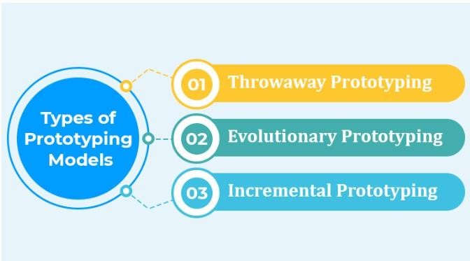

*Figure 3Types of Prototyping Models*

###### 1. Throwaway Prototyping

Rapid Throwaway Prototyping is a technique used in software development to quickly create a simplified version of a system. The primary goal is to gather immediate feedback from users and stakeholders about the system's requirements and design. This prototype is developed with minimal effort and resources, often focusing only on specific aspects of the system that need clarification. Once the prototype is reviewed and feedback is collected, it is discarded rather than being refined or expanded. The insights gained from this process are then used to inform the next iteration of the requirements and design, helping to ensure that the final product better meets user needs and expectations. While this approach can help to quickly identify and resolve misunderstandings early in the development process, it can also result in wasted effort if the prototypes are not effectively managed or if they diverge too significantly from the final product's envisioned scope. (aws, 2024)

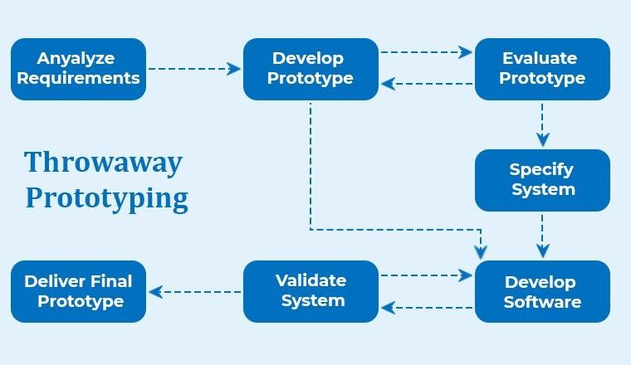

*Figure 41.Throwaway Prototyping*

##### Steps and Process

1. Gather initial requirements.
2. Develop a quick and rough prototype.
3. Get feedback from users.
4. Discard the prototype.
5. Refine requirements and repeat as necessary.

##### Advantages and Disadvantages of Throwaway Prototyping

|  |  |
| --- | --- |
| **Advantages** | **Disadvantages** |
| Quick Feedback: Rapid throwaway prototyping enables fast feedback from users, allowing developers to understand user needs and preferences early in the project. | Resource Waste: The prototype is discarded after use, which can lead to a perceived waste of time and resources if not managed properly. |
| Clarifies Requirements: This strategy clarifies imprecise or incomplete requirements, lowering the likelihood of misunderstandings later in the development process. | User Confusion: If the prototype differs greatly from the finished product, it may generate misunderstanding among consumers and stakeholders. |
| Cost-Effective: By identifying issues early, can reduce the cost of changes, which would be more expensive to implement in later stages. | Limited Reusability: Components of the throwaway prototype are often not reusable in the final system, necessitating duplicate efforts. |
| Improves Communication: Improves communication between developers and stakeholders, ensuring that everyone has a clear knowledge of the project's direction. | Temporary Fixes: Temporary solutions may be mistaken for permanent ones, which might lead to problems if they are not durable or scalable. |
| Reduces Risk: Early validation of concepts and ideas helps in identifying potential risks and issues before significant resources are invested. | Scope Creep: Users might request additional features or changes based on the prototype, which can lead to scope creep if not controlled. |

*Table 2Advantages and Disadvantages of Throwaway Prototyping*

##### 2. Evolutionary Prototyping

Another type of prototyping is an evolutionary prototype. Evolutionary prototypes are created by the team in an incrementally refined manner after accepting the customer’s final feedback. This type of prototyping enables the team to save a lot of development time and effort. And the main reason behind it is that the development of a prototype from scratch for every different interaction can be very frustrating. (aws, 2024)

Evolutionary prototyping is a software development method that involves creating a working model early and continuously refining it based on user feedback. This incremental approach allows developers to build a system, incorporating feedback and changes as the project progresses. However, careful management is necessary to avoid scope creep.

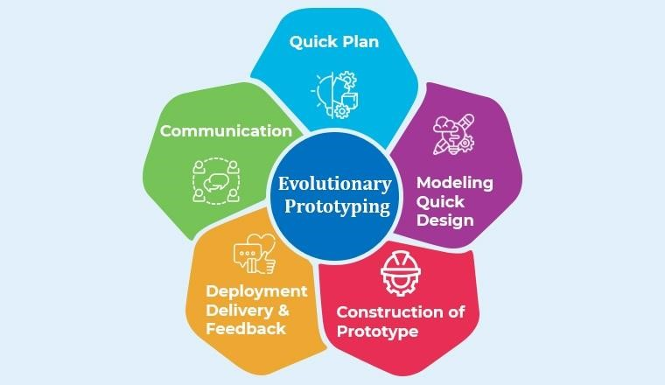

*Figure 52 Evolutionary Prototyping*

##### Steps and Process

1. Gather initial requirements.
2. Develop an initial prototype.
3. Get feedback from users.
4. Refine and improve the prototype iteratively.
5. Evolve the prototype until it becomes the final product.

##### Advantages and Disadvantages of Evolutionary Prototyping

|  |  |
| --- | --- |
| **Advantages** | **Disadvantages** |
| Users are involved throughout the development process, ensuring that their needs and preferences are consistently incorporated into the evolving product. | Continuous adjustments and additions can result in scope creep, in which the project expands beyond its initial objective, thereby generating delays and increased expenses. |
| Frequent interactions with users assist to clarify and revise requirements, lowering the likelihood of misunderstandings and erroneous assumptions. | The iterative nature of evolutionary prototyping can be resource-intensive, requiring continuous involvement from both developers and users. |
| The approach allows for changes and new requirements to be easily integrated into the system, making it adaptable to evolving user needs and market conditions. | Managing a growing prototype involves meticulous preparation and coordination to ensure that modifications are smoothly incorporated and do not disturb current functionality. |
| Potential issues and design faults may be recognized and corrected early in the development process, resulting in a more robust final product. | Without a well-defined plan, the final product can become disorganized, leading to a system that is harder to maintain and scale. |
| Working versions of the system are delivered incrementally, allowing users to see progress and providing an opportunity for early use of certain features. | The iterative cycles of refinement and feedback can extend the overall development timeline, especially if the requirements continue to evolve significantly. |

*Table 3Advantages and Disadvantages of Evolutionary Prototyping*

Evolutionary prototyping provides substantial benefits in terms of user engagement and adaptability, resulting in a final product that is closely matched with user requirements. However, careful management is required to prevent scope creep, resource waste, and structural difficulties. When properly maintained, it may produce in a reliable and user-friendly system.

##### 3. Incremental Prototyping

Incremental is a type of prototyping that enables the division of the final product into smaller prototypes and then they are developed individually. This means that different prototypes can be merged into a single software. This approach is used to reduce the feedback time between the application development team and the user. (aws, 2024)

Incremental prototyping is a software development technique that breaks down a system into manageable increments, allowing users to provide feedback before the next increment is developed. This approach manages complexity, allows early delivery of useful features, and refines subsequent increments to meet user requirements. However, careful planning and integration are required to ensure a cohesive final system.

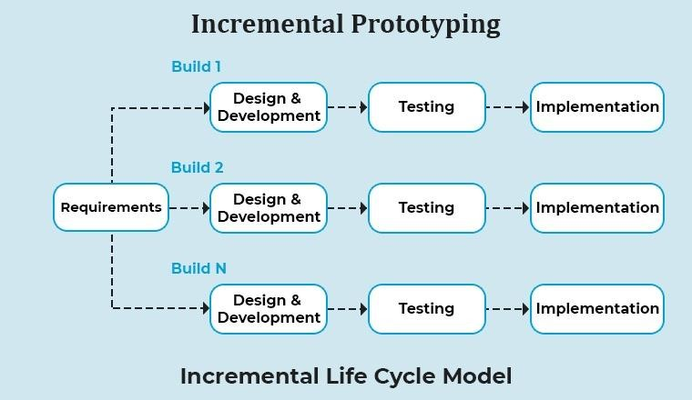

*Figure 63Incremental Prototyping*

##### Steps and Process

1. Divide the system into smaller, manageable parts.
2. Develop and deliver prototypes for each part incrementally. 3) Get feedback and refine each part.

4) Integrate all parts into a final system

##### Advantages and Disadvantages Incremental Prototyping

|  |  |
| --- | --- |
| **Advantages** | **Disadvantages** |
| Users can start using parts of the system before the entire project is completed, providing immediate value and benefits. | Combining these increments into a unified final system may be difficult, necessitating meticulous planning and organization. |
| By constructing the system in smaller chunks, any faults may be recognized and handled early on, lowering the likelihood of serious problems later in the project. | Dependencies between increments must be carefully controlled to ensure that changes in one do not negatively impact the others. |
| Changes in requirements can be more easily managed and incorporated into subsequent increments, allowing for greater adaptability to evolving user needs. | Effective incremental prototyping requires thorough upfront planning to define increments and ensure their integration. |
| Smaller, incremental pieces are easier to test and debug, resulting in higher-quality, more dependable components. | Managing multiple iterations and ensuring they fit together can introduce additional overheads in terms of time and resources**.** |
| Continuous user feedback on each increment helps ensure that the final system better meets user expectations and requirements. | Keeping the scope under control can be difficult, as users may seek extra capabilities based on the capability provided in the early stages. |
| Different increments can be developed in parallel, speeding up the overall development process. | Early increments may have limited functionality, which might not fully satisfy user needs until later stages. |

*Table 4Advantages and Disadvantages Incremental Prototyping*

Incremental prototyping has various benefits, including faster delivery, greater flexibility, and better risk management. However, careful preparation, coordination, and dependency management are required to ensure successful integration and minimize possible hazards. When done well, it may result in a well-organized, user-centered end system.

## 1.3 Using Prototypes to Test Functionalities and End-User Testing Requirements

### Low-Fidelity Prototypes

A picture is worth a thousand words" is one of the most famous adages in design. Simply put, it means a single still image can convey incredibly complex or sophisticated ideas. Low-fidelity (lo-fi) designs are the initial glance of a future product and help team members evaluate design ideas and concepts.

Speed of creation and simplicity of design are two integral properties of low-fidelity design. (Babich, 2022)

Low-fidelity prototypes are early-stage representations or mockups of a product or system that are designed to quickly and simply convey basic design concepts and functionalities. These prototypes are typically created using basic materials such as paper, sketches, wireframes, or simple digital tools

##### Advantages and Disadvantages Low-Fidelity Prototypes

|  |  |
| --- | --- |
| **Advantages** | **Disadvantages** |
| Cost-effective: They are generally quick and inexpensive to create, allowing for rapid iteration and testing without heavy investment. | Limited Detail: Low-fidelity prototypes may lack the detail needed to fully simulate the user experience, which could lead to  misunderstandings or misinterpretations |
| Focus on Functionality: Because they are plain and straightforward, they allow for a greater emphasis on functionality and user flow over aesthetics. | Less Realistic: Stakeholders and users might not fully grasp the final product’s potential from low-fidelity prototypes, potentially affecting decision-making. |
| Early Feedback: They enable early-stage feedback from stakeholders and users, which helps in identifying potential issues and improvements early in the design process. | Focus on Functionality Only: Because they stress utility, there is a danger of overlooking essential visual and aesthetic features that might affect the user experience. |
| Ease of Iteration: Changes and iterations are easier to implement due to the simplicity of the prototype | Potential Misinterpretation: Stakeholders may sometimes misinterpret the simplicity of low fidelity prototypes as indicative of final product quality or features. |

*Table 5Advantages and Disadvantages Low-Fidelity Prototypes*

### High-fidelity

High-fidelity prototypes are advanced representations of software products that are painstakingly created using sophisticated design tools to closely resemble the final application's appearance and performance. They incorporate interactive elements and imitate user interactions, giving stakeholders a realistic preview of the final product. These prototypes are extremely useful for usability testing, allowing designers and developers to collect exact input on user experience, functionality, and visual design. High-fidelity prototypes, which display complex graphics and interactive features, allow for extensive examination and refining of the user interface, ensuring that the final product closely corresponds with user expectations and project goals from the start.

##### Advantages and Disadvantages of High-fidelity

|  |  |
| --- | --- |
| **Advantages** | **Disadvantages** |
| Realistic Representation: High-fidelity prototypes closely resemble the final product in terms of visual design and interactive elements, providing stakeholders with a realistic preview. | Time-Consuming: Creating high-fidelity prototypes can be time-consuming due to the level of detail and complexity involved, potentially delaying the development process. |
| Detailed Feedback: They allow stakeholders to give explicit and thorough comments on user interface design, functionality, and interactions. | Costly: They are more expensive to produce than low-fidelity prototypes, as they often require advanced design tools and skills. |
| Usability Testing: Facilitates usability testing to identify usability issues, navigation challenges, and user experience improvements early in the development process. | Limited Flexibility: Changes and revisions to high-fidelity prototypes can be more challenging and time-consuming compared to low-fidelity prototypes. |
| Stakeholder Buy-In: Helps gain stakeholder buy-in and approval by providing a tangible representation of the final product, reducing misunderstandings, and aligning expectations. | Misinterpretation: Users and stakeholders may mistake high-fidelity prototypes for the final product, expecting full functionality and performance, which can lead to misunderstandings and dissatisfaction if expectations are not managed properly. |

*Table 6Advantages and Disadvantages of High-fidelity*

##### Beta Versions

The beta version, a pre-release build of software that may contain bugs or performance issues, is released after the alpha phase in the software release life cycle. While alpha testing is typically conducted internally, beta testing is focused on testing the software with a group of end users. The distinctions between alpha and beta versions lie in the testing audience, the objectives of testing, and the timeline of each stage. (rader, 2024)

Beta versions are advanced stages of software development, released to external users for real-world testing. They include most intended features and allow for comprehensive evaluation of performance, usability, and functionality, enabling developers to resolve issues before official release.

##### Advantages and Disadvantages Beta Versions

|  |  |
| --- | --- |
| **Advantages** | **Disadvantages** |
| Real-World Testing: Beta versions allow for testing in real-world environments, providing valuable insights into how the software performs under actual usage conditions. | Resource Intensive: Managing beta testing requires significant resources, including time, personnel, and infrastructure, to support and respond to user feedback. |
| Early Feedback: External users can provide feedback on usability, functionality, and performance, helping identify bugs and usability issues that may have been overlooked. | Potential Risks: Users may encounter critical bugs or issues in the beta version, which could lead to negative feedback and impact the software's reputation. |
| Bug Identification: Helps in identifying and fixing bugs and issues that may not have been discovered during internal testing, leading to a more stable final release. | Scope Management: Changes to features and functionalities may need to be frozen or delayed to avoid disrupting the testing process, and limiting flexibility. |
| User Acceptance: This provides an opportunity to gauge user acceptance and satisfaction with the software before its official launch, potentially increasing user adoption. | Security Concerns: Exposing the software to external users during beta testing can pose security risks if adequate precautions are not taken to protect sensitive data. |

*Table 7Advantages and Disadvantages Beta Versions*

## 1.4 End-User Testing

End-user testing, also known as user acceptance testing (UAT), is a vital stage in the software development lifecycle in which actual end-users review the software program in a real-world setting prior to its final release. The fundamental purpose of end-user testing is to guarantee that the software fulfills business requirements and performs as expected by the user. This testing phase is dedicated to confirming the software's usability, functionality, performance, and overall user experience.

End-users, who represent the software's target audience or stakeholders, complete a variety of activities and scenarios to determine how effectively the application supports their workflows and satisfies their requirements. End-user testing, as opposed to testing conducted by developers or quality assurance teams, gives vital insights into how the program will work in real-world situations.

By actively involving end-users in testing, organizations can identify and address potential issues, usability challenges, and discrepancies between user expectations and the actual software functionality. This feedback loop is crucial for refining the software, enhancing user satisfaction, and ensuring that the final product delivers value to its intended users. (Deveraj, 2024)

### Benefits of End-User Testing

**Validation of Requirements**: Validation of requirements is a crucial process in software development, ensuring the final product meets user needs and expectations. It involves checking software alignment with documented requirements, often through end-user testing. This process helps identify discrepancies between user needs and software capabilities, reducing post-deployment issues and enhancing software quality and reliability. It builds stakeholder confidence in the final product's value and objectives.

**Optimizing User Interface Design:** User Testing: User testing provides feedback on the overall design aesthetics, brand perception, and emotional impact of your product. It helps ensure that the visual elements resonate with users and contribute positively to their overall experience**.** Usability testing is a crucial process that refines user interfaces for optimal navigation, guiding element placement, label clarity, and layout layout to enhance user efficiency. Utilizing user and usability testing insights can result in a visually appealing, intuitive, and user-friendly interface that perfectly meets user expectations.

**Early Issue Identification**: Early issue identification is a crucial practice in software development, involving identifying and addressing problems early. This proactive approach, implemented through testing phases like unit and integration testing, helps maintain project timelines, prevent technical debt accumulation, and improve software quality and reliability. It also contributes to user satisfaction by meeting expectations and reducing post-deployment failure risks.

**Enhancing Task Efficiency**: User Testing: User testing sheds light on the overall user journey, helping identify areas where users may encounter inefficiencies or roadblocks in achieving their goals. Usability testing is a task-centric approach that assesses the effectiveness of a user interface by measuring task completion time, error rates, and completion rates. Benefit: By combining insights from user testing and usability testing, you can streamline the user journey, making it not only enjoyable but also time-efficient and frustration-free.

**Risk mitigation:** Risk mitigation in software development involves identifying and addressing potential risks early in the project lifecycle through activities like requirement analysis, code reviews, and UAT. This proactive strategy helps teams develop contingency plans, maintain project timeline and budgets, reduce post-deployment costs, enhance software quality and reliability, and boost stakeholder confidence.

**Iterative Improvement**: User Testing: The iterative nature of user testing allows for continuous refinement of the product based on evolving user needs, preferences, and feedback. Usability testing is a crucial step in product development, ensuring each iteration improves the user interface and enhances the overall product experience.

**Quality assurance (QA)** is a systematic process in software development that aims to ensure the final product meets defined standards of quality, reliability, and performance. It involves activities like requirement analysis, code inspections, continuous integration, testing, and performance evaluations. Implementing robust QA practices improves user experience, reduces post-deployment failures, and fosters a culture of continuous improvement within development teams.

### End-User Testing

End-user testing, also known as user acceptance testing (UAT), employs various methods to ensure the software meets user requirements and functions correctly in real-world scenarios.

Alpha Testing

Description: Conducted by internal staff, often within the development team, to identify and fix bugs before releasing the software to external users.

Objective: Catch major issues early in a controlled environment.

Beta Testing

Description: Releases the product to a restricted number of external users who are not part of the development team.

Objective: Gather feedback on usability, functionality, and performance in real-world settings.

Scenario Testing:

Description: Users perform specific tasks or scenarios that simulate real-world use cases to evaluate how well the software supports their workflows.

Objective: Ensure the software meets user needs in practical situations.

Exploratory Testing:

Description: Users explore the software freely without predefined test cases to uncover unexpected issues or usability challenges.

Objective: Identify defects and usability problems through unstructured testing.

### Objectives of End-User Testing

Objectives of End-User Testing:

Objective: Confirm that all features and functions of the software work as intended according to the specified requirements.

Benefit: Ensures the software fulfills its primary purposes and supports the users' tasks effectively.

Usability Evaluation:

Objective: Assess the software's ease of use, intuitiveness, and overall user experience.

Benefit: Enhances user satisfaction by making the software accessible and user-friendly.

Performance Assessment:

Objective: Evaluate the software's performance under various conditions, including speed, responsiveness, and scalability.

Benefit: Ensures the software can handle expected loads and performs efficiently without degradation.

Reliability and Stability:

Objective: Verify that the software operates reliably without crashes or significant bugs under normal and peak usage conditions.

Benefit: Builds confidence in the software's stability, reducing the risk of post-deployment failures.

Compliance and Compatibility:

Objective: Ensure the software complies with relevant standards, and regulations, and is compatible with different operating systems, browsers, and hardware configurations.

Benefit: Guarantees broader usability and adherence to legal and technical requirements.

## 1.5 Prototype Tools

Prototyping tools are platforms designers use to create interactive mockups of digital products, such as websites, mobile apps, or software interfaces. These tools help designers visualize and demonstrate the functionality, layout, and user experience of their designs before they fully develop or implement them. Usually, these tools offer a range of features and functionalities, including drag-and-drop interfaces, pre-built UI components, interactive elements, animation capabilities, and collaboration tools. (Team, 2024)

In general, they serve several purposes in the prototyping process:

**Conceptualization:** Prototyping tools help designers translate their ideas and concepts into tangible elements.

**Communication:** Prototypes are a visual communication tool that allows designers to better communicate their design thoughts and intents to stakeholders, developers, and other team members than static wireframes or mockups.

**Iterative design**: Prototyping tools enable designers to quickly create, modify, and revise prototypes based on feedback and insights they gather during the design process.

**User testing:** Designers can employ prototypes in user testing sessions to evaluate the usability, functionality, and overall user experience of a design. User feedback collected from prototype testing informs design improvements and optimizations.

**Ease of use:** Look for a tool with an intuitive interface and simple controls to simplify prototyping for everyone and speed up the workflow process.

**Functionality:** Depending on your project needs, you may require simple wireframing skills, interactive prototyping, animation tools, or complex interactions.

**Compatibility**: Compatibility with design tools like Sketch, Figma, or Adobe XD can streamline your workflow and facilitate seamless collaboration between design and development teams.

#### 1.5.1 Hypermedia Management tools

Hypermedia management tools are specialized software applications designed to facilitate the creation, organization, and presentation of multimedia content in a structured and interactive format. These tools are essential for integrating diverse types of media such as text, graphics, audio, video, and hyperlinks into cohesive presentations or applications. They enable users to author and edit multimedia content, define navigational paths for users to explore, and incorporate interactive elements like clickable links and multimedia players. Hypermedia management tools are widely used in industries such as education, marketing, entertainment, and e-learning, where engaging and interactive presentations are crucial. By providing capabilities for content integration, interactive navigation, and multimedia authoring, these tools empower users to create dynamic and impactful multimedia experiences that enhance engagement, communication, and learning outcomes.

##### Features of Hypermedia Management Tools

**Content Integration:** They allow users to integrate various types of multimedia content into a cohesive structure. This integration can include linking different media types together to create interactive presentations or applications.

**Interactivity:** Hypermedia tools frequently include interactive components like clickable links, navigation menus, interactive maps, and integrated multimedia players. This interaction improves user engagement and usability.

**Multimedia Authoring:** They provide tools for creating and editing multimedia content. This can include features for editing images and videos, recording and editing audio, and designing graphical elements.

**Navigation and Structure**: Hypermedia technologies allow users to define the content's navigation structure. This entails designing hierarchies, menus, and paths for people to move through the multimedia information.

**Presentation and Delivery:** These tools offer features for presenting and delivering multimedia content to users, including online publishing, exporting presentations, and hosting on web servers.

##### Advantages and Disadvantages of Hypermedia Management tools

|  |  |
| --- | --- |
| **Advantages** | **Disadvantages** |
| Hypermedia technologies enable the development of interactive and multimedia-rich material, increasing user engagement and understanding. | Some hypermedia technologies have a high learning curve, particularly for users with low technical knowledge. Mastering advanced features and functions may take a substantial amount of time and effort. |
| These tools can be used across various industries and applications, from education and training to marketing, entertainment, and beyond. | Ensuring smooth integration of numerous multimedia elements while maintaining consistency across several platforms and devices can be difficult and may necessitate additional resources. |
| They facilitate the clear and effective conveyance of complicated concepts and information through multimedia displays and interactive aspects. | High-quality hypermedia tools may need licensing fees and additional features or upgrades, which might be prohibitively expensive for smaller businesses or individuals. |
| Hypermedia tools allow for the inclusion of interactive elements such as clickable links, quizzes, simulations, and multimedia players, which improve user interaction and participation. | Running and using certain hypermedia tools may require specific hardware configurations or software dependencies, limiting accessibility for users with older or less capable devices. |
| They enable the integration of several media types (text, images, audio, and video) into a coherent framework, resulting in a richer and more thorough display of information. | Managing and organizing vast amounts of multimedia material using hypermedia platforms may be difficult, necessitating sophisticated content management techniques and tools. |
| They enable the integration of several media types (text, images, audio, and video) into a coherent framework, resulting in a richer and more thorough display of information. | Regular maintenance and updates are necessary to ensure compatibility with new technologies, security patches, and evolving user expectations, which can add to the overall cost and effort of using these tools. |

*Table 8Advantages and Disadvantages of Hypermedia Management tools*

#### 1.5.2 Content Management System

A Content Management System (CMS) is a software application that enables users to create, edit, manage, and publish digital content with ease. It provides a user-friendly interface that allows individuals, even those with limited technical expertise, to manage content on websites, blogs, and other digital platforms. A CMS typically includes features for content creation and editing, media management, workflow automation, and access control, allowing multiple users to collaborate on content development. Popular examples of CMSs include WordPress, Joomla, and Drupal. By simplifying the content management process, a CMS enhances productivity, ensures consistency, and facilitates the timely updating and maintenance of digital content, making it an essential tool for businesses, organizations, and individuals who need to manage their online presence effectively.

##### Features of Content Management System

**Content Creation and Editing:** A CMS provides tools for users to create and edit content without needing extensive technical skills. This typically includes a WYSIWYG (What You See Is What You Get) editor that allows users to format text, insert images, and embed videos easily.

**Content Storage and Organization**: A content management system (CMS) organizes material by storing text, pictures, and other media in databases. This structure facilitates the retrieval and management of material.

**Publishing and Workflow Management:** A CMS often includes features to manage the publishing workflow, such as draft creation, review, approval processes, and scheduling of content publication.

This ensures that content is reviewed and approved before going live.

**User Management and Access Control**: A CMS enables administrators to control user roles and permissions, ensuring that only authorized users may create, modify, and publish material. This is critical to ensuring the content's integrity and security.

**Themes and Templates:** CMS platforms usually offer a variety of themes and templates to design the appearance of the website. Users can customize these themes to match their branding and aesthetic preferences without needing to write code.

**Plugins and Extensions:** Many CMS platforms support plugins or extensions that add additional functionality, such as SEO tools, social media integration, e-commerce capabilities, and more. This extensibility allows users to tailor the CMS to their specific needs.

##### Advantages and Disadvantages of Content Management System

|  |  |
| --- | --- |
| **Advantages** | **Disadvantages** |
| CMS platforms often offer WYSIWYG editors and drag-and-drop functionality, enabling nontechnical users to create and manage content without requiring knowledge of HTML, CSS, or other programming languages. | While basic tasks are user-friendly, more advanced customization can require technical knowledge, such as HTML, CSS, JavaScript, or PHP. |
| Content is stored in a structured database, making it easy to organize, search, and retrieve. | Without proper caching and optimization, CMSbased websites can suffer from slow load times. |
| The system monitors content modifications and enables users to revert back to previous versions if necessary. | Popular CMS platforms are common targets for hackers. Regular updates and security patches are essential to mitigate vulnerabilities. |
| Multiple users can work on content simultaneously, with defined roles and permissions ensuring proper access control. | Some CMS platforms, especially enterpriselevel ones, come with licensing fees. |
| Content can go through a review and approval process before being published, ensuring quality and consistency. | Regular upgrades and maintenance are required to keep the CMS safe and functional, which can be time-intensive. |
| CMS platforms offer a variety of themes and templates that can be customized to match branding and design preferences. | Updates to the CMS core, themes, or plugins can sometimes cause compatibility issues, requiring troubleshooting and fixes. |
| A wide range of plugins or extensions can add functionality, such as SEO tools, social media integration, e-commerce capabilities, and more | While many CMS platforms can support large expansion, excessive scalability may need specialized solutions or extensive customization, potentially resulting to performance issues. |
| CMS platforms often support integration with other software and services through APIs. | Costs for premium themes, plugins, and hosting can add up |
| Many CMS platforms include tools for optimizing content for search engines. | Plugins and extensions can introduce security risks if not regularly updated or properly vetted. |

*Table 9Advantages and Disadvantages of Content Management System*

#### 1.5.3 Interface Builders Tools

Interface builder tools are specialized software applications that enable designers and developers to create user interfaces (UI) for applications without having to write code from scratch. These tools offer a graphical interface where users can drag and drop UI elements like buttons, text fields, images, and menus onto a canvas, arranging them to design the layout of the application. Interface builders also allow users to define the properties and behaviors of these UI elements, such as colors, fonts, and interactions. By providing a visual representation of the user interface, these tools streamline the design process, improve collaboration between designers and developers, and enable rapid prototyping and iteration. Popular interface builder tools include Adobe XD, Sketch, Figma, and the Interface Builder in Xcode for iOS development. These tools are essential in modern application development, helping to ensure that the final product is user-friendly, visually appealing, and functional.

##### Features of Interface Builder Tools

**Drag-and-Drop Interface:** Users can drag and drop UI elements such as buttons, text fields, images, and sliders onto a canvas. This visual approach makes it easier to conceptualize and design the user interface.

**Real-Time Design:** Changes made in the interface builder are mirrored in real time, allowing designers to see how the UI will appear and work right away. This facilitates quick prototyping and iteration.

**Property Inspectors:** Interface builders include property inspectors, which allow users to configure and alter the attributes of UI components such as size, color, font, and alignment. These properties may be changed without writing any code.

**Interaction Design:** Users may customize the behavior of UI components, such as what occurs when a button is pressed or how a menu expands. This includes creating event handlers and attaching UI components to functions or actions.

**Layout and Constraints:** Tools frequently incorporate layout restrictions, which ensure that the UI adjusts properly to multiple screen sizes and orientations. This is critical for developing responsive designs.

##### 1) web interface development tools

The user interfaces (UIs) of websites and online applications are created, managed, and optimized with the help of web interface development tools, which are specialized software programs and platforms. Numerous capabilities offered by these tools facilitate the development process, increase productivity, and guarantee that the final web interfaces are useful, easy to use, and aesthetically pleasing.

Features of Web Interface Development Tools

**Code Editors and Integrated Development Environments (IDEs):** These tools highlight different parts of the code in various colors, making it easier to read and understand, Provides suggestions as you type, speeding up coding and reducing errors. Integrated debugging tools help identify and fix errors in the code.

**Frameworks and Libraries:** Libraries like Bootstrap, Foundation, and Materialize provide predesigned components and templates to create responsive and consistent UIs quickly. Libraries such as React, Angular, and Vue.js help in building dynamic and interactive web applications**.**

**Design and Prototyping Tools:**  Tools like Balsamiq, Sketch, and Adobe XD allow designers to create wireframes and prototypes of web interfaces, Enables the creation of clickable prototypes to simulate user interactions and gather feedback before development begins.

**Version Control Systems:** A widely used version control system that tracks code changes and allows multiple developers to collaborate on the same project, Provides repositories for code storage, collaboration features, and version tracking**.**

#### 1.5.4. 4th Generation Systems

Fourth-generation systems, often called 4G systems, represent a significant evolution in telecommunications technology, providing high-speed internet access and advanced communication capabilities. These systems leverage advanced modulation schemes, such as OFDM (Orthogonal Frequency Division Multiplexing), and sophisticated coding techniques to achieve faster data transfer rates and improved spectral efficiency. 4G systems enable seamless streaming of high-definition video, real-time gaming, and efficient handling of large data volumes, making them ideal for applications such as video conferencing and mobile broadband. Additionally, 4G networks support enhanced mobile experiences through better connectivity, lower latency, and greater capacity, which are crucial for modern applications in various sectors, including healthcare, education, and business. By offering ubiquitous connectivity and robust performance, 4G systems have set the stage for integrating more complex and data-intensive applications, paving the way for developing even more advanced technologies like 5G.

Features of 4th generation systems

High Data Transfer Rates: 4G networks provide significantly faster data transfer rates compared to previous generations, enabling high-speed internet access for activities such as streaming HD videos, online gaming, and large file downloads.

Enhanced Connectivity: With better connectivity and coverage, 4G networks ensure a more reliable and consistent user experience, even in densely populated or remote areas.

Low Latency: 4G systems offer reduced latency, making real-time applications such as video conferencing, online gaming, and VoIP (Voice over Internet Protocol) more responsive and effective.

Improved Spectral Efficiency: Using advanced modulation schemes like OFDM (Orthogonal Frequency Division Multiplexing) and MIMO (Multiple Input Multiple Output) technology, 4G networks achieve better utilization of the available spectrum, increasing the overall network capacity.

Support for Multimedia Applications: 4G networks are designed to handle multimedia applications seamlessly, allowing users to enjoy high-quality video streaming, online gaming, and rich media content without interruptions.

Increased Network Capacity: The advanced infrastructure of 4G networks supports a larger number of connected devices, accommodating the growing demand for mobile internet access and the proliferation of IoT (Internet of Things) devices.

Global Roaming: 4G systems support global roaming, enabling users to stay connected with highspeed internet access while traveling internationally.

#### 1.5.5 object-oriented application framework

An object-oriented application framework is a reusable, semi-complete software structure that provides a foundation for developing applications within a specific domain. By utilizing the principles of object-oriented programming (OOP), such as inheritance, polymorphism, and encapsulation, these frameworks offer a robust and flexible architecture that can be extended and customized to meet specific requirements. Key components of an object-oriented framework include classes, objects, and methods, which encapsulate both data and behaviors, promoting modularity and code reuse. This structure allows developers to build applications more efficiently by leveraging pre-defined, tested components and focusing on the unique aspects of their projects. Additionally, object-oriented frameworks often provide a set of tools and libraries that simplify common tasks such as user interface design, data management, and network communication. As a result, they enable faster development cycles, improved code maintainability, and enhanced scalability, making them an essential asset in modern software engineering.

##### Features Object-oriented application framework

Object-oriented application frameworks provide a variety of features that enhance software development by promoting modularity, reusability, and maintainability. Key features include:

Reusability: Frameworks offer reusable components and libraries, allowing developers to leverage pre-existing code for common functionalities, reducing development time and effort.

Modularity: By organizing code into distinct classes and objects, frameworks facilitate modularity, making it easier to manage, understand, and modify complex applications.

Inheritance: Frameworks support inheritance, allowing developers to create new classes based on existing ones, promoting code reuse and simplifying the implementation of common patterns.

## 1.6 Tools used for prototyping

##### Adobe Xd

Adobe XD is a powerful, vector-based tool for digital design and prototyping user interfaces (UI) and user experiences (UX). Adobe XD has a wide range of features and applications, making it an essential tool for any UX designer.

Its capabilities include optimized performance, a clean interface, and an expansive set of features. One key feature is the live preview, which allows designers to see changes in real time. Another is the repeat grid, which makes it easy to create complex layouts with multiple elements. Adobe XD also offers support for voice commands and gestures, making it a great option for designing interactive prototypes. (Team, 2024)

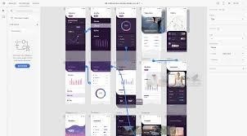

*Figure 7Adobe Xd*

##### Features of Adobe Xd

Adobe XD is a comprehensive tool for UI/UX design that offers a range of powerful features tailored to streamline the design process. At its core, XD is vector-based, allowing for precise and scalable designs. One standout feature is the Repeat Grid, which enables designers to duplicate and repeat content seamlessly, making it ideal for creating lists and galleries. The tool also supports the creation of reusable components, ensuring consistency across multiple artboards and projects. Responsive Resize automatically adjusts and scales content to fit different screen sizes, while Auto-Animate allows for the creation of sophisticated animations and transitions, simulating real user interactions.

For asset export, XD provides multiple format options, including PNG, SVG, and PDF.

Adobe XD excels in prototyping with interactive, voice, overlay, and visualization features. It enhances collaboration, maintains consistency, and allows for direct feedback through commenting and version control for tracking iterations. Adobe XD is a versatile tool that seamlessly integrates with other Adobe Creative Cloud apps and third-party tools, offering easy access, collaboration, and version control across projects, and is designed for fast, responsive performance across macOS and Windows.

##### Advantages and Disadvantages of Adobe XD

|  |  |
| --- | --- |
| **Advantages** | **Disadvantages** |
| Adobe XD's intuitive interface and integration with other Adobe Creative Cloud apps make it accessible to both beginners and experienced designers. | While XD covers most basic and intermediate design needs, some advanced features found in other specialized design tools might be missing or less robust. |
| Vector-based design, Repeat Grid, and  Responsive Resize enhance efficiency in design, enabling quick creation of detailed, scalable, and responsive designs. | Users who are not familiar with Adobe products might face a steeper learning curve compared to those who have experience with other Adobe Creative Cloud apps. |
| The tool's advanced prototyping features, such as interactive prototypes, voice prototyping, overlay support, and Auto-Animate, enable designers to create realistic user experiences. | Running Adobe XD, especially on large projects, can be resource-intensive and may require a powerful computer to ensure smooth performance. |
| Adobe XD enables real-time collaboration among multiple designers, improving communication with stakeholders through feedback and commenting features. | Adobe XD is part of Adobe’s Creative Cloud subscription, which can be costly, especially for individual designers or small teams. |
| Reusable components and the ability to manage design systems help maintain consistency across projects and streamline the design workflow. | Features like cloud documents and collaboration require a stable internet connection, which can be a limitation in areas with poor connectivity. |
| XD is designed to be fast and responsive, even when handling complex designs and large files, ensuring a smooth user experience. | While cloud-based features offer advantages in collaboration and access, they can be restrictive for users who need to work offline frequently. |

*Table 10Advantages and Disadvantages of Adobe XD*

##### Figma

Figma is a cloud-based design tool that allows designers to collaborate in real-time. It is used for creating user interfaces, wireframes, prototypes, and other design elements. One of Figma's key features is its ability to enable multiple designers to work on the same project simultaneously, facilitating seamless collaboration and feedback. It also supports version control, making it easy to track changes and revert to previous versions if needed. Figma is accessible through a web browser, eliminating the need for software installations and allowing for easy access from any device. Its robust set of design tools, coupled with its collaborative capabilities, makes Figma a popular choice among design teams and individual designers alike. (Academy, 2023)

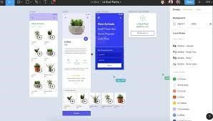

*Figure 8 Figma*

##### Features of Figma

Real-Time Collaboration: Multiple designers can work on the same project simultaneously, making it easy to collaborate, share ideas, and receive instant feedback.

Cloud-Based Platform: As a web-based tool, Figma doesn't require any software installation and can be accessed from any device with an internet connection.

Vector Networks: Figma's unique vector networks provide more flexibility and precision in designing complex shapes and paths.

Prototyping: Designers can create interactive prototypes directly within Figma, enabling them to test and iterate on designs without needing to switch between different tools.

Components: Reusable design elements called components help maintain consistency across designs and streamline the design process.

Design Systems: Figma supports the creation and management of design systems, ensuring consistency and efficiency across large projects and teams.

Version Control: All changes are automatically saved, and version history allows designers to track changes and revert to previous versions when needed.

##### Advantages and Disadvantages of Figma

|  |  |
| --- | --- |
| **Advantages** | **Disadvantages** |
| Multiple users can work on a project simultaneously, making it easy for teams to collaborate and provide feedback in real time. | Being cloud-based means that an internet connection is required to access and work on projects, which can be a limitation in areas with poor connectivity. |
| Accessible from any device with an internet connection, eliminating the need for software installations and making it easy to work from anywhere. | Large or complex projects can sometimes cause performance slowdowns, especially on less powerful hardware. |
| Intuitive and easy to use, making it suitable for both beginners and experienced designers | While the basic interface is user-friendly, mastering advanced features and workflows can take time. |
| Allows for the creation of interactive prototypes directly within the platform, streamlining the design and testing process. | Offline work is limited, which can be inconvenient for users who need to work without an internet connection. |
| Supports reusable components and design systems, which help maintain consistency and efficiency across projects. | Although there is a free tier, advanced features and team collaboration tools require a paid subscription, which can be a consideration for budget-conscious users or small teams. |
| Automatic saving and version history make it easy to track changes and revert to previous versions if needed. | Since it runs in a web browser, it may not be as responsive or feature-rich as some native applications, potentially leading to limitations in certain functionalities. |
| Works on Windows, Mac, and Linux systems through a web browser, ensuring compatibility across different operating systems. | Storing designs in the cloud can raise privacy and security concerns for sensitive projects, especially in industries with strict data protection regulations. |
| Offers a wide range of integrations with other tools and a variety of plugins to extend functionality and enhance workflow. | While Figma supports basic prototyping and interactivity, its animation capabilities are not as advanced as some other dedicated animation tools. |

*Table 11Advantages and Disadvantages of Figma*

##### UXPin

UXPin is a powerful design and prototyping tool that enables designers to create interactive, highfidelity prototypes for web and mobile applications. It offers a comprehensive suite of features, including drag-and-drop functionality, pre-built UI elements, and advanced prototyping capabilities like conditional logic, states, and variables. UXPin also supports real-time collaboration, allowing design teams to work together seamlessly and iterate quickly. Additionally, it integrates with popular design and development tools, making it easy to incorporate UXPin into existing workflows. With its user-friendly interface and robust feature set, UXPin helps designers bridge the gap between design and development, ensuring a smoother transition from prototype to production. (Riva, 2023)

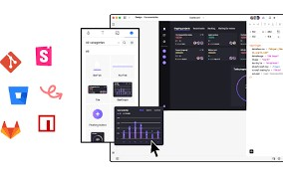

*Figure 9 UXPin*

##### Features of UXPin

Interactive Prototyping: Create interactive prototypes with advanced features like conditional logic, states, and variables to simulate real user interactions.

Drag-and-Drop Functionality: Easily build prototypes using a drag-and-drop interface with access to a library of pre-built UI elements and components.

Real-Time Collaboration: Collaborate with team members in real time, allowing multiple designers to work on the same project simultaneously and see changes instantly.

Design Systems: Create and manage design systems to maintain consistency across projects. UXPin allows for the creation of reusable components and libraries.

Integration with Design Tools: Seamlessly integrates with popular design tools such as Sketch, Photoshop, and Figma, enabling designers to import and sync their work.

Developer Handoff: Generate specifications and code snippets to facilitate a smooth handoff to developers, reducing the gap between design and development.

##### Advantages and Disadvantages of UXPin

|  |  |
| --- | --- |
| **Advantages** | **Disadvantages** |
| Advanced prototyping capabilities, such as conditional logic and variables, enable designers to create highly interactive and realistic prototypes. | The extensive feature set can result in a steep learning curve for new users, particularly those unfamiliar with advanced prototyping techniques. |
| Real-time collaboration allows multiple team members to work together seamlessly, enhancing communication and speeding up the design process. | UXPin can be relatively expensive compared to other design tools, which might be a consideration for smaller teams or individual designers. |
| Ability to create and manage design systems ensures consistency across projects and facilitates the reuse of components, saving time and effort. | Performance issues may arise with complex prototypes, especially when working with a large number of interactive elements or highfidelity designs. |
| Integrates well with popular design tools like Sketch, Photoshop, and Figma, allowing for easy import and synchronization of designs. | As a cloud-based tool, UXPin requires an internet connection, limiting its usability when offline access is needed |
| Streamlined handoff process with generated specifications and code snippets helps bridge the gap between design and development, reducing errors and improving efficiency. | While UXPin integrates with many popular tools, there may be limitations or challenges when integrating with less common or custom tools used by some teams. |
| Supports designing for various screen sizes and devices, ensuring a consistent user experience across different platforms. | Some users might find the customization options limited compared to other design tools, particularly for highly specialized design needs. |
| Facilitates usability testing by sharing interactive prototypes with users and gathering feedback to refine designs. | The library of pre-built UI elements, while extensive, may not always cover all the specific needs of every project, requiring additional customization. |

*Table 12Advantages and Disadvantages of UXPin*

##### Vectr

Vectr is a free graphics software used to create vector graphics easily and intuitively. It's designed to be simple yet powerful, allowing users to design everything from business cards to web graphics, icons, and more. Vectr runs online and offline, making it accessible across different platforms. Its collaborative features enable real-time sharing and editing of designs, making it suitable for both individual designers and teams working together on projects. With its user-friendly interface and basic to advanced tools, Vectr aims to democratize vector graphic design, offering a viable alternative to more complex and expensive software in the market. (Sawyer, 2024)

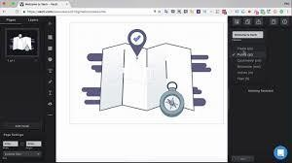

*Figure 10Vectr*

##### Features of Vectr

Free and Cross-Platform: Vectr is free to use and works seamlessly on both web and desktop platforms (Windows, macOS, Linux).

Intuitive Interface: Designed to be user-friendly, Vectr provides a straightforward interface that simplifies the process of creating vector graphics.

Real-Time Collaboration: Users can collaborate in real-time by sharing designs with others, enabling simultaneous editing and commenting.

Vector Editing Tools: Vectr includes essential vector editing tools such as Pen Tool, Node Tool, and Shape Tools for creating and manipulating shapes, paths, and curves.

Import and Export: Supports importing SVG, PNG, and JPEG files for editing, and allows exporting designs in SVG, PNG, and JPEG formats.

Cloud Integration: Vectr offers cloud storage for saving and accessing designs from anywhere, facilitating easy workflow management.

##### Advantages and Disadvantages of Vectr

|  |  |
| --- | --- |
| **Advantages** | **Disadvantages** |
| Vectr has a straightforward interface that makes it easy for beginners to start creating vector graphics without a steep learning curve. | Compared to more advanced vector graphics software like Adobe Illustrator, Vectr may have fewer advanced features and tools, limiting its capabilities for complex design projects. |
| It works on multiple platforms (web, Windows, macOS, Linux), allowing users to access and work on their designs from different devices. | Some users may experience performance issues, especially when working with large or complex designs, due to its online and browser-based nature. |
| Enables real-time collaboration, where multiple users can work together on the same design simultaneously, enhancing teamwork and productivity. | While Vectr offers offline mode, certain advanced features and functionalities may be restricted or unavailable without an internet connection. |
| Offers cloud storage for saving and accessing designs, ensuring files are securely stored and easily retrievable from anywhere. | Real-time collaboration and cloud storage features require an internet connection, which may not be ideal for users in areas with unstable internet connectivity. |
| Vectr is free, making it accessible to users who may not have the budget for more expensive design software. | While easy to start with, mastering advanced features and techniques in Vectr may require additional time and effort compared to more specialized software. |
| Provides various export options (SVG, PNG, JPEG) with control over settings like resolution and transparency, ensuring designs can be used across different platforms and mediums. | Although it supports common file formats, Vectr's export options and customization capabilities may be limited compared to premium vector graphics software. |

*Table 13Advantages and Disadvantages of Vectr*

##### MockFlow

MockFlow is a comprehensive online toolset designed for UI/UX designers and product managers to create wireframes and prototypes effortlessly. It offers a range of features including wireframing, design collaboration, user interface design, and interactive prototyping. MockFlow's intuitive interface allows users to quickly sketch out ideas, collaborate with team members in real time, and simulate interactive user experiences. It's particularly valued for its ease of use, extensive widget libraries, and the ability to seamlessly transition from wireframes to prototypes, making it a valuable tool in the design and development workflow. (crozdesk, 2024)

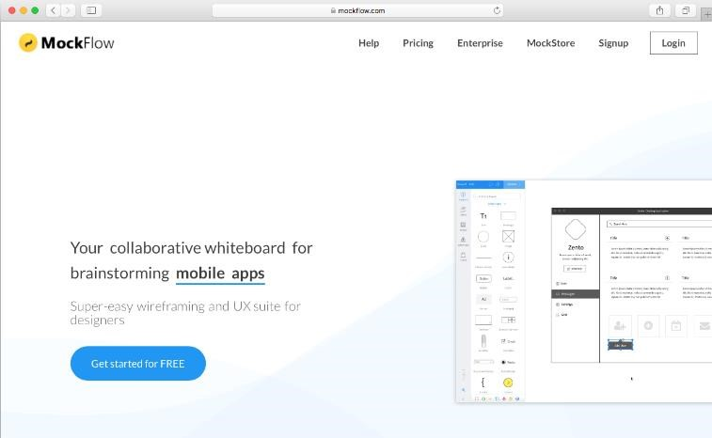

*Figure 11MockFlow*

##### Features of MochFlow

Wireframing: Create wireframes quickly using a drag-and-drop interface with a wide range of predesigned components and widgets.

Prototyping: Turn wireframes into interactive prototypes to simulate user interactions and workflows.

Collaboration: Real-time collaboration tools allow team members to work together on designs, leave comments, and provide feedback instantly.

Design Libraries: Access extensive libraries of UI elements, icons, and templates to speed up the design process.

Responsive Design: Design interfaces that adapt to different screen sizes and devices, ensuring compatibility and usability across platforms.

Version History: Track changes and revert to previous versions if needed, ensuring design integrity and accountability.

Export and Sharing: Export designs in various formats (PDF, PNG, HTML) and share prototypes with stakeholders for feedback and testing

##### Advantages of Disadvantages of mockflow

|  |  |
| --- | --- |
| **Advantages** | **Disadvantages** |
| MockFlow offers a user-friendly interface with drag-and-drop functionality, making it easy for designers to create wireframes and prototypes quickly. | While MockFlow offers a free version with limited features, access to advanced features and larger team collaboration may require a subscription, which can be costly for some users. |
| Real-time collaboration features allow team members to work together seamlessly, share feedback, and iterate on designs efficiently | Despite its user-friendly interface, mastering all features and maximizing efficiency may require some initial learning and practice |
| It provides a comprehensive library of UI components, icons, and templates, which speeds up the design process and ensures consistency. | Being an online tool, MockFlow requires a stable internet connection to access and use, which may be inconvenient in certain situations |
| Designers can create interactive prototypes to simulate user interactions and test usability before development begins | While it provides a rich library of components, customization options for certain elements may be limited compared to other design tools. |
| It offers version history and revision tracking, enabling designers to revert to previous versions or track changes easily**.** | Integrating MockFlow with other software or platforms may require additional setup or compatibility considerations, depending on the user's workflow and requirements. |

*Table 14Advantages of Disadvantages of mockflow*

# Activity 02

## 1.6 Introduction of End User

The term "end user" refers to the consumer of a good or service, often who has some innate knowhow that is unique to consumers. In a literal sense, the term end user is used to distinguish the person who purchases and uses the good or service from individuals who are involved in the stages of its design, development, and production. (Kindness, 2023)

End consumers are people or organizations who plan to utilize a product or service in the end. The ultimate users of a program or system are referred to as end users in the area of technology and software. When creating solutions that are both user-friendly and efficient, their demands and experiences are crucial. Comprehending the behavior, preferences, and difficulties of end users is crucial to developing solutions that satisfy their needs while simultaneously improving their overall pleasure and productivity. Businesses may guarantee increased adoption rates, improved user engagement, and enduring customer loyalty by concentrating on end user-centric techniques.

#### 1.6.1 Define End-User Categorization and Classification

##### Role of Usage

Primary users are individuals who directly engage with a product or service, relying on its functionality to fulfill their specific needs or goals. For example, project managers and team members use software for planning, tracking progress, and collaboration.

On the other hand, secondary users are those who indirectly benefit from or facilitate the use of the product or service by primary users. This group includes administrators, supervisors, support staff, or other personnel who oversee operations, provide technical assistance, or manage the system on behalf of primary users. Their role is crucial in ensuring the smooth operation, maintenance, and support of the product or service, thus supporting the effectiveness and satisfaction of primary users. In the project management software example, secondary users might include IT administrators who manage user access and troubleshoot technical issues, or supervisors who oversee project timelines and resource allocation without directly managing tasks themselves.

##### Frequency of Use

In terms of frequency of use, regular users are individuals who engage with a product or service consistently and frequently as part of their regular routines or activities. These users rely on the product regularly to perform tasks, access information, or enjoy its benefits on a recurring basis. For example, in a subscription-based streaming service like Netflix, regular users would be those who log in multiple times per week to watch movies or TV shows, making the service a routine part of their entertainment consumption.

Occasional users use a product or service sporadically, often when specific needs arise or circumstances warrant it. They may be freelance designers or seasonal users. Understanding these users helps businesses tailor support, user interface, and marketing strategies to enhance user engagement and satisfaction across different usage patterns.

##### Expertise Level

In terms of expertise level, users can be categorized based on their proficiency and familiarity with a product or service. Novice users are individuals who are new to using the product or service and typically require guidance, instruction, or training to become proficient. They may be unfamiliar with the interface, features, or specific workflows and may need assistance to navigate and utilize the product effectively. For example, novice users of a complex software application like Adobe Photoshop might require tutorials or guided tours to understand basic tools and editing functions.

Intermediate users have moderate proficiency in a product or service, capable of performing basic tasks independently but may require assistance for advanced features or troubleshooting. They are comfortable with tasks, deadlines, and collaboration.

Advanced users have high proficiency in using product features and can use advanced tools to maximize productivity. They can manipulate complex datasets, create custom queries, and generate detailed reports without external support. Understanding user expertise helps businesses tailor interfaces, provide support, and develop training programs.

##### Behavior or Preferences

Segmented users are categorized based on specific behaviors, preferences, or characteristics, allowing businesses to understand and cater to their unique needs. For instance, a clothing retailer can segment users based on age, gender, and style to optimize product offerings and customer engagement.

Targeted users are identified for targeted marketing efforts based on their specific needs, interests, or purchase history. These campaigns address pain points, increase conversion rates, foster customer loyalty, and enhance satisfaction. Both segmented and targeted user approaches are crucial in modern marketing and customer relationship management, enabling businesses to optimize resources and deliver relevant experiences.

##### Organizational Context

In the organizational context, users can be categorized into individual users and enterprise users based on how they interact with and utilize a product or service.

Individual users are single users who independently utilize the product or service for their personal or professional needs. They may be consumers or small businesses that rely on the product or service on an individual basis. For example, an individual user of a project management tool might use it to manage personal projects or freelance work, accessing and utilizing the software without requiring collaboration with others.

Enterprise users are organizations adopting products or services across multiple departments, requiring collaborative features, centralized administration, and scalability. They include sales, marketing, and customer support teams, managing client interactions, tracking leads, and coordinating efforts. Businesses must differentiate between individual and enterprise users in product design, pricing, and customer support. Individual users prioritize ease of use, affordability, and flexibility, while enterprise users prioritize scalability, security, and integration capabilities.

#### 1.6.2 Types of End Users

End users can be categorized into several types based on their roles, needs, and interactions with technology. Here are some common types of end users,

Casual Users: These users have minimal interaction with the system and use it occasionally for basic tasks. They typically require intuitive interfaces and straightforward functionality.

Power Users: Power users are proficient in using the system and often utilize advanced features and functionalities. They may require more in-depth training and access to administrative controls.

Administrative Users: These users manage and maintain the system, overseeing permissions, configurations, and security settings. They require comprehensive access and knowledge of the system's backend operations.

Technical Users: Technical users are often IT professionals or developers who interact with the system at a deeper technical level, troubleshooting issues, writing scripts, or customizing functionalities.

External Users: These users are outside the organization but interact with the system, such as customers, clients, or partners. They may have limited access to specific features tailored to their needs.

Mobile Users: With the rise of mobile technology, these users primarily interact with systems via mobile devices, requiring interfaces optimized for smaller screens and touch input.

Remote Users: Remote users work away from the central office or system location. They require secure access and robust connectivity solutions to interact effectively with the system.

Specialized Users: Some systems cater to specialized roles such as healthcare professionals, researchers, or designers. These users require tailored functionalities that meet their specific industry or job requirements.

Understanding these user types helps in designing user interfaces, providing appropriate training and support, and ensuring that systems meet diverse user needs effectively.

## 1.7 Define behavior modeling, for prototyping.

##### Introduction of behavior Modelling

Behavior modeling, or behavioral modeling, refers to the way companies approach and assess the ways their customers behave. Companies use the ways their customers behave in a selection of contexts, developing an understanding of the way prospective buyers respond in several situations and the benefits of acting in a manner that makes the most of this behavior. This ultimately attempts to not only predict the actions of parties such as customers, members of staff, or other companies in the market but also consider the reason that people make these behavioral choices. (Team, 2024)

Behavior modeling is a psychological theory that explains how individuals learn new behaviors by observing others. It emphasizes the role of imitation and observational learning in the acquisition of skills, attitudes, and behaviors. According to this theory, people can learn from models (individuals demonstrating behaviors) in their environment, whether those models are real or fictional. The process involves attention to the model's actions, retention of the observed behavior in memory, reproduction of the behavior when appropriate, and motivation to imitate based on perceived rewards or consequences. Behavior modeling suggests that learning can occur through indirect experiences, allowing individuals to acquire new behaviors without direct reinforcement or trial-and-error learning, thus influencing personal development and social interactions.

**Observation:** Individuals observe the behavior of others, especially those they perceive as role models or experts in a particular context.

**Imitation:** After observing a behavior, individuals attempt to replicate or imitate it in their own actions.

**Learning:** Through this process, learning occurs as individuals internalize and practice the behavior they have observed.

**Reinforcement:** The effectiveness of behavior modeling often depends on reinforcement — positive consequences for correctly imitating the behavior or negative consequences for incorrect or undesired behaviors.

**Role Models:** Role models play a crucial role in behavior modeling. They can be real individuals or fictional characters portrayed in media, such as movies, TV shows, or books.

### Advantages and disadvantages of behavior modeling

|  |  |
| --- | --- |
| **Advantages** | **Disadvantages** |
| Hands-on Experience: Observing and imitating behaviors provides practical, hands-on learning experiences, which can enhance skill acquisition and retention. | The efficiency of behavior modeling is heavily influenced by the quality of the model under observation. Poor role models might encourage the adoption of undesirable habits. |
| Visual learners find task performance more effective than reading or hearing instructions. | Inconsistencies in behavior among different models can confuse learners. |
| Behavior modeling enhances learning by providing clear examples of desired behaviors and techniques. | abilities: Behavior modeling is less successful in teaching abilities and information that are not visible, such as critical thinking and problem-solving. |
| Enhances social and interpersonal abilities by demonstrating good communication and engagement. | Exposure to undesirable or improper actions can lead to imitation of the same habits, especially among vulnerable people. |
| It aids in the transmission of cultural practices, traditions, and values through observation. | habits that are beneficial in one environment may not be acceptable in another, resulting in the incorrect application of learned habits. |
| Helps individuals adapt to new cultural environments by observing and imitating local behaviors. | Cultural differences can affect the interpretation and effectiveness of observed behaviors. |
| Behavior modeling is applicable in education, workplace training, therapy, and even technology development. | Individual differences in learning styles, capacities, and preferences may not be taken into consideration when imitating behavior. |
| Useful in AI and machine learning for creating predictive models based on observed behaviors. | It can be less personalized compared to other teaching methods, potentially leaving some learners behind. |

*Table 15Advantages and disadvantages of behavior modeling*

### Empathy mapping

An empathy map is a simple, easy-to-digest visual that captures knowledge about a user’s behaviors and attitudes. It is a useful tool to help teams better understand their users. Empathy mapping is a simple workshop activity that can be done with stakeholders, marketing and sales, product development, or creative teams to build empathy for end users. For teams involved in the design and engineering of products, services, or experiences, an empathy mapping session is a great exercise for groups to “get inside the heads” of users.

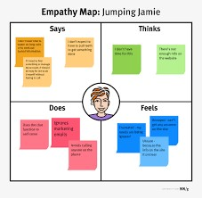

*Figure 12Empathy mapping*

Understanding the millennial mindset is crucial in user experience design. Millennials value authentic, personalized experiences and are highly influenced by social proof and peer recommendations. They seek products and services that resonate with their values, such as sustainability and cultural relevance. To effectively cater to millennials, empathy mapping can be a powerful tool. This article explores the evolving landscape of travel consumerism, particularly focusing on the influence of the Millennial mindset on destination marketing. (Brown, 2020)

Empathy maps are most useful at the beginning of the design process after user research but before requirements and concepts. The mapping process can help synthesize research observations and reveal deeper insights about a user’s needs. (The maps are most effective when based on research data, but like provisional personas, can be built using knowledge from internal participants or using existing personas.) It can help guide the construction of personas or serve as a bridge between personas and concept deliverables.

In the context of prototyping, empathy mapping serves as a crucial step in understanding users deeply and applying those insights to the design process. Here are the steps involved in empathy mapping specifically tailored to prototyping, along with how they facilitate the designing process.

##### 1. Research and Data Collection

Purpose: Gather qualitative data through user interviews, surveys, observations, or existing research.

Facilitates Designing: Provides foundational insights into user behaviors, needs, and pain points, which are essential for creating prototypes that address real user problems.

##### 2. Identify User Personas

Purpose: Create detailed personas representing different user segments based on collected data.

Facilitates Designing: Personas help in empathizing with specific user groups during the design process, ensuring prototypes are tailored to their unique needs and preferences.

##### 4. Empathy Map Creation

Purpose: Construct an empathy map with sections for what users Say, Think, Feel, Do, Pains, and Gain.

Facilitates Designing: Provides a visual framework to consolidate and organize user insights. It helps designers and teams empathize more deeply with users, guiding decisions about prototype features, interactions, and user interface elements.

**5. Analyzing and Synthesizing Insights:**

Purpose: Analyze collected data and empathy map insights to identify patterns, trends, and key user needs.

Facilitates Designing: Ensures that prototypes address the most critical user problems and opportunities. Synthesizing insights helps prioritize features and functionalities that will have the most impact on user satisfaction and usability.

### Customer journey mapping

A customer journey map is a visual depiction of the stages customers go through when interacting with a company -- from buying products online to accessing customer service on the phone to airing grievances on social media.

To create effective visual maps that reflect customers' journeys through these channels, journey maps must be rooted in data-driven research and visually represent the different phases customers experience based on a variety of dimensions, including customer sentiment, business goals and touchpoints. (Yasar, 2024)

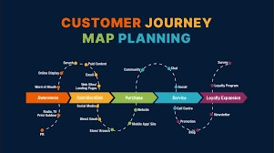

*Figure 13Customer journey mapping*

Customer journey mapping is a strategic tool used to visualize and understand the entire experience a customer has with a product or service across various touchpoints. It involves mapping out every interaction and emotion a customer may encounter from initial awareness, through the purchasing process, and into post-purchase support and beyond. By capturing these touchpoints, emotions, and pain points, businesses can identify opportunities for improvement, enhance customer satisfaction, and optimize their processes to better meet customer needs and expectations throughout the entire journey.

Customer journey mapping is a crucial step in UX and service design, visualizing the end-to-end customer interaction with a product or service, facilitating the design process.

##### 1. Define Objectives and Scope

Set Goals: Determine what you want to achieve with the journey map. This could be improving a specific part of the user experience, identifying pain points, or understanding the overall customer journey.

Scope Definition: Decide on the scope of the journey you want to map. It could be a high-level overview of the entire customer lifecycle or a detailed look at a specific interaction.

##### 2. Create Customer Personas

Research: Gather data on your customers through surveys, interviews, analytics, and other research methods.

Persona Development: Create detailed customer personas that represent different segments of your customer base. Include demographic information, needs, goals, and pain points.

##### 3. Identify Touchpoints

List Touchpoints: Identify all the points where customers interact with your product or service. This includes before, during, and after the actual use of the product.

Categorize: Group these touchpoints into different stages of the customer journey, such as awareness, consideration, purchase, use, and post-purchase.

**4. Map the Current Journey:** visualization: Create a visual representation of the current customer journey. This can be a simple flowchart or a more detailed infographic.

Detail Steps: For each touchpoint, describe the actions, emotions, and thoughts of the customer. Note any pain points or areas where the experience can be improved.

##### Experience mapping

User Experience Mapping, also known as Customer Journey Mapping (CJM) is a powerful technique for understanding what motivates your customers - what their needs are, their hesitations, and concerns. Although most organizations are reasonably good at gathering data about their customers, data alone fails to communicate the frustrations and experiences the customers experienced. A story can do that, and one of the best storytelling tools in business is the user experience map.

User Experience Mapping is a powerful technique for understanding what motivates your customers - what their needs are, their hesitations, and their concerns. Although most organizations are reasonably good at gathering data about their customers, data alone fails to communicate the frustrations and experiences the customers experience. A story can do that, and one of the best storytelling tools in business is the user experience map. (Paradigm, 2023)

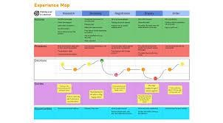

*Figure 14Experience mapping*

Experience mapping, also known as customer journey mapping, is a technique used to understand and visualize the steps a user takes to achieve a specific goal with a product or service. This method helps designers create more user-centered prototypes. Here are the key steps of experience mapping and how they facilitate the designing process:

##### 1. Define Objectives and Scope

Objectives: Determine the purpose of the experience map. What do you hope to achieve with this map? What are the key questions you want to answer?

Scope: Decide on the specific user journey to map. This could be the entire user experience with a product or a specific part of it.

##### 2. User Research

Gather qualitative and quantitative data about your users. This can include user interviews, surveys, usability testing, and analytics.

Identify key personas that represent different user types.

1. **Identify User Stages:**

Break down the user journey into distinct stages or phases. These stages will vary depending on the product but often include steps like awareness, consideration, purchase, onboarding, and retention.

1. **Create a Timeline:**

Map out the sequence of events and actions taken by the user. This timeline helps visualize the flow of interactions.

1. **Touchpoints and Channels:**

Identify all the touchpoints where users interact with the product or service. Touchpoints can include physical locations, digital interfaces, customer service interactions, etc.

Specify the channels used (e.g., mobile app, website, phone, in-person).

##### Service blueprinting

A service blueprint expands on a customer journey map. It details every interaction a customer has with an organization during their lifecycle. This blueprint goes deeper and examines all supporting physical and digital interactions. It often appears as a diagram with swim lanes. Each lane represents a specific category. Arrows link interactions between lanes to show the workflow.

Service blueprints enable great service. The world-leading customer service trainer, Kate Zabriskie, says, “Although your customers won’t love you if you give bad service, your competitors will.”

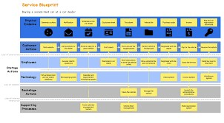

*Figure 15 Service blueprinting*

Service blueprinting is a strategic tool used to design and visualize service processes, mapping out the customer journey and the corresponding interactions with the service provider. This detailed visualization includes customer actions, frontstage (visible) and backstage (invisible) employee actions, support processes, and physical evidence that customers encounter. By separating these components with lines of interaction, visibility, and internal interaction, service blueprinting helps organizations identify pain points, streamline processes, and enhance overall customer experience. It improves communication among stakeholders, aids in training and development, and fosters innovation by highlighting gaps and opportunities for improvement. Ultimately, service blueprinting serves as a valuable framework for optimizing service delivery and ensuring a seamless and efficient experience for customers.

Service blueprinting is a strategic tool used in service design to visually map out the processes involved in delivering a service. It helps identify potential pain points, streamline processes, and improve customer experiences. Here are the key steps involved in service blueprinting in prototyping and how they facilitate the designing process

##### 1. Identify the Service Process

Define the scope of the service to be analyzed. Identify the key processes and steps involved in delivering the service.

This helps in setting clear boundaries and focus areas for the blueprint.

**2. Map Customer Actions:**

List all the actions taken by the customer while engaging with the service. This includes every interaction from the beginning to the end of the service. This ensures a customer-centric approach, highlighting the customer's journey and touchpoints.

##### 3. Identify Frontstage/Visible Contact Employee Actions

Document the actions performed by employees that are visible to the customer. This helps in understanding the direct interactions between customers and service staff, ensuring smooth and efficient service delivery.

1. **Identify Backstage/Invisible Contact Employee Actions:**

Record the actions taken by employees that are not visible to the customer but are essential for service delivery. This step highlights the behind-the-scenes efforts, ensuring that all necessary support activities are in place.

1. **Map Support Processes:**

Identify and document all the internal processes and systems that support the frontstage and backstage actions.This ensures that all supportive activities and infrastructure are aligned with the service delivery.

## 1.8 Appropriate prototyping methodology for the given scenario

For developing an online courier management system like TravelBuddies.com, selecting an appropriate prototyping methodology is crucial for ensuring that the end product meets the needs of all users effectively. Given the scenario and the need for a highly interactive, web-based system with multiple user roles and modules, the Evolutionary Prototyping methodology is the most suitable.

Evolutionary Prototyping

Evolutionary Prototyping involves building a prototype incrementally based on feedback and requirements gathered from users at various stages. This approach allows continuous refinement and enhancement of the prototype until it evolves into the final product.

Reasons for Selecting Evolutionary Prototyping:

##### 1. Continuous User Feedback

In a system with diverse user roles (registered user, guest, admin, pickup staff, delivery staff), it’s essential to gather continuous feedback from each user group. Evolutionary prototyping facilitates this by allowing users to interact with the prototype regularly and provide feedback on functionality, usability, and performance.

##### 2. Incremental Development

The development can be broken down into manageable chunks. Each module (Booking, Login, Complaint Management, etc.) can be developed, tested, and refined in iterations. This ensures that each part of the system is functional and meets user expectations before moving on to the next module.

##### 3. Flexibility in Requirements

As the project progresses, new requirements or changes to existing ones can be easily incorporated. This is especially important for a dynamic system like a courier management system, where business needs and user expectations might evolve.

##### 4. Risk Mitigation

By continuously testing and validating the prototype, risks related to usability, functionality, and integration can be identified and addressed early in the development process, reducing the likelihood of significant issues at later stages.

##### 5. User-Centered Design

This approach ensures that the end product is highly user-centric. Regular interactions with users help in understanding their needs better and designing a system that provides a seamless experience for all user roles.

##### Conclusion

Evolutionary prototyping is well-suited for the development of TravelBuddies.com due to its iterative nature, focus on continuous user feedback, and ability to adapt to changing requirements. This methodology allows for the incremental development of the system, ensuring that each module is thoroughly tested and refined before moving on to the next. By continuously involving users from various roles (registered users, guests, admins, pickup staff, and delivery staff), the evolving prototype can be tailored to meet their specific needs and expectations. This user-centric approach not only helps in identifying and addressing potential issues early on but also ensures that the final product is robust and user-friendly. Overall, evolutionary prototyping ensures that TravelBuddies.com is a comprehensive and effective courier management system that aligns with the dynamic needs of the business and its users.

## 1.9 End user selection for the scenario

The specified modules for the online courier management system TravelBuddies.com, the end-user selection for each role can be outlined as follows:

##### Registered User

The Registered User role in the TravelBuddies.com online courier management system encompasses several key functionalities designed to enhance user interaction and satisfaction. The Booking Module provides users with the ability to seamlessly book courier services online, facilitating convenient scheduling and ensuring efficient handling of consignments. Through the Login Module, registered users can securely access their accounts, enabling personalized services such as viewing booking history, managing preferences, and accessing additional features tailored to their needs.

The Complaint Management Module and Consignment Tracking Module enhance the user experience by allowing users to file complaints, track progress, and monitor consignment status. These modules promote transparency, customer satisfaction, and efficient booking, thereby improving TravelBuddies.com courier management system.

##### Guest

The Guest role in the TravelBuddies.com online courier management system provides essential functionalities tailored to users who prefer not to create an account but still require basic services. In the Booking Module, guests have limited access to book courier services directly through the system without the need to register an account. This streamlined process allows guests to enter necessary shipment details, select service options, and confirm bookings swiftly and conveniently.

The Consignment Tracking Module offers limited real-time tracking for guests, providing essential updates on their shipments. While not offering advanced features like account management or historical tracking data, these functionalities enhance the guest experience on TravelBuddies.com.

##### Admin

The Admin role in the TravelBuddies.com online courier management system holds comprehensive authority and responsibility across all system functionalities, ensuring smooth operation and efficient service delivery. With full access to all modules, admins can manage and oversee every aspect of the system, starting from the Booking Module, where they can review and manage booking activities to optimize resource allocation and customer service. Admins control the Complaint Management Module and Report Module, enabling timely resolution of customer issues and providing insights into operational efficiency and performance metrics.

Moreover, The admin role at TravelBuddies.com is crucial in managing logistics operations, scheduling, and maintaining system functionality. It involves overseeing Pickup and Delivery Modules, optimizing routes, and monitoring staff performance, ensuring system integrity and customer satisfaction.

##### Admin

The Admin role within the TravelBuddies.com online courier management system is pivotal, encompassing full access to all modules to effectively manage and optimize system operations. Admins oversee the Booking Module, facilitating efficient booking processes and ensuring seamless customer interactions. They manage the Complaints Module, promptly addressing customer concerns to maintain service quality and client satisfaction. Admins use Report Module to generate system reports, optimize Pickup and Delivery Modules, and monitor staff performance for strategic decisionmaking and service delivery enhancement.

Furthermore, admins play a crucial role in the Maintenance Module, ensuring regular system updates, security patches, and maintenance tasks are performed promptly. This proactive approach ensures the system remains secure, stable, and capable of meeting evolving business needs. Overall, the Admin role is integral to maintaining the integrity, efficiency, and customer satisfaction of the TravelBuddies.com courier management system through comprehensive oversight, strategic management, and continuous improvement initiatives across all system functionalities.

##### Pickup Off

The Pickup Staff role in the TravelBuddies.com online courier management system is designed to streamline and optimize the pickup process, ensuring efficient handling of consignments from the point of collection. With access to the Pickup Module, staff members can view and manage pickup requests, prioritize schedules based on logistical requirements, and confirm pickups promptly. This functionality allows them to maintain a structured approach to handling pickups, ensuring timely and reliable service for customers.

The Login Module allows Pickup Staff to access their accounts securely, ensuring accountability and communication. The Consignment Tracking Module allows real-time updates, enhancing transparency and service quality. These modules contribute to operational efficiency and customer satisfaction within the TravelBuddies.com courier management system.

##### Delivery Staff

The Delivery Staff's role in the TravelBuddies.com online courier management system is essential for ensuring the timely and accurate delivery of consignments to customers. With access to the Delivery Module, staff members can efficiently manage delivery requests, prioritize schedules based on logistical needs, and confirm deliveries upon completion. This module provides them with a structured approach to handling deliveries, ensuring that consignments reach their destinations promptly and in optimal condition.

Furthermore, The Consignment Tracking Module empowers Delivery Staff to update the status of consignments in real-time during the delivery process. This capability ensures transparency and enables customers and administrators to track the progress of deliveries accurately. By utilizing these modules effectively, Delivery Staff contribute to enhancing customer satisfaction, maintaining service reliability, and optimizing overall operational efficiency within the TravelBuddies.com courier management system.

# Activity 03

### 3.1 Discuss the sketching phase of the site

**Sketch**

The sketching process plays a crucial role in UI/UX design as it facilitates the exploration of different design concepts and ideas swiftly and effectively. Sketching serves to communicate design concepts and ideas, typically depicted in rough, hand-drawn depictions that allow designers to think creatively and identify potential issues, refining their designs before progressing to more formalized versions. As a valuable tool for gathering stakeholder feedback and communicating ideas, sketching enables designers to effectively convey their thoughts.

This article will delve into the significance of sketching in UI/UX design, the various types of sketches, tips and techniques for sketching, and the available tools for designers to create sketches. (Adesina, 2023)

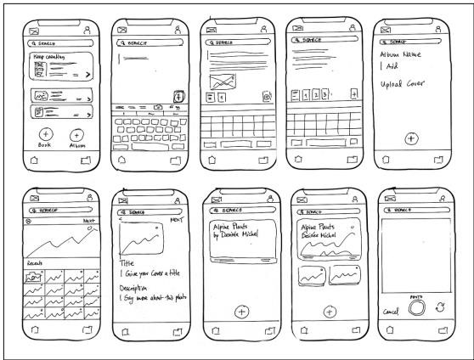

*Figure 16 Sketch*

##### Features of Sketch

Vector-Based Design: Sketch employs vector graphics for scalable designs without compromising quality, making it ideal for creating responsive designs that can adapt to various screen sizes and resolutions.

Artboards: Artboards in Sketch allow designers to create multiple canvases within a single document.

This is useful for designing different screens of an app or website within one file.

Symbols and Components: Designers can create reusable elements known as symbols. These symbols can be updated globally, ensuring consistency across the design. Components can be nested and have overrides for further customization.

Styles and Shared Styles: Sketch enables the creation of reusable text and layer styles, ensuring consistent typography, colors, and effects throughout the design process.

###### Advantages and Disadvantages of Sketch

|  |  |
| --- | --- |
| **Advantages** | **Disadvantages** |
| User-Friendly Interface: Sketch has a clean, intuitive, and easy-to-navigate interface, making it accessible for both beginners and experienced designers. | Mac-Only: Sketch is a software exclusively available on macOS, limiting its accessibility to designers using Windows or Linux systems. |
| Vector-Based Design: Sketch uses vector graphics, allowing designs to be scaled without losing quality, which is crucial for responsive and high-resolution designs. | Performance Issues: Sketch may experience performance issues, such as lag or slow loading times, when dealing with large or complex files. |
| Symbols and Reusability: Sketch enables users to create reusable symbols and components that can be globally updated, thereby ensuring consistency across a project. | Learning Curve for Advanced Features: While the basic features are user-friendly, mastering more advanced functionalities and plugins may require time and effort. |
| Collaboration: Sketch Cloud provides real-time collaboration features for designers, allowing them to share work and receive feedback, making it crucial for team projects. | Limited Animation Tools: Sketch's built-in animation and interaction design tools are less advanced than specialized tools like Adobe After Effects or Principles. |
| Prototyping Tools: Sketch includes built-in prototyping tools that enable designers to create interactive prototypes without needing additional software. | Dependency on Plugins: While the availability of plugins is an advantage, it also means that users may become dependent on third-party tools for certain functionalities, which can lead to compatibility and maintenance issues. |
| Community and Resources: A strong community and wealth of online resources, tutorials, and templates make it easier for users to learn and enhance their skills. | Cost: Sketch's paid license may pose a challenge for freelancers or small teams with limited budgets, as it also incurs ongoing costs for updates and maintenance. |

*Table 16Advantages and Disadvantages of Sketch*

#### 3.1.1 Sketches for the provided scenario

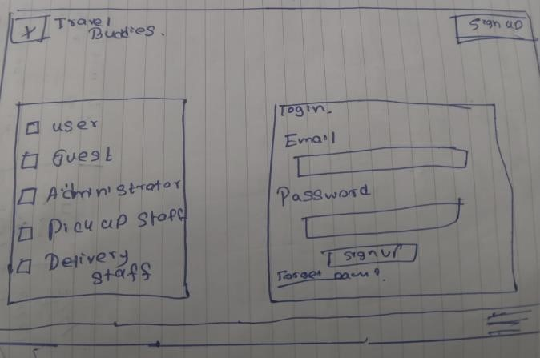

*Figure 17 login sketch*

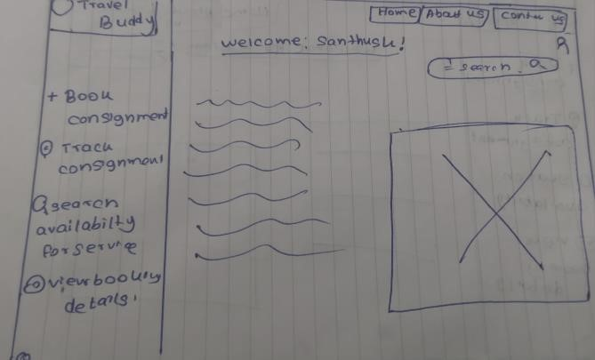

*Figure 18 User sketch*

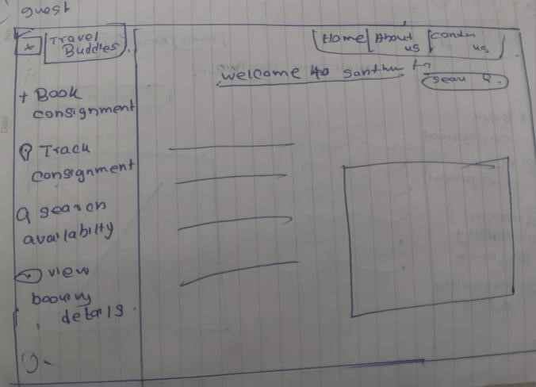

*Figure 19 guest sketch*

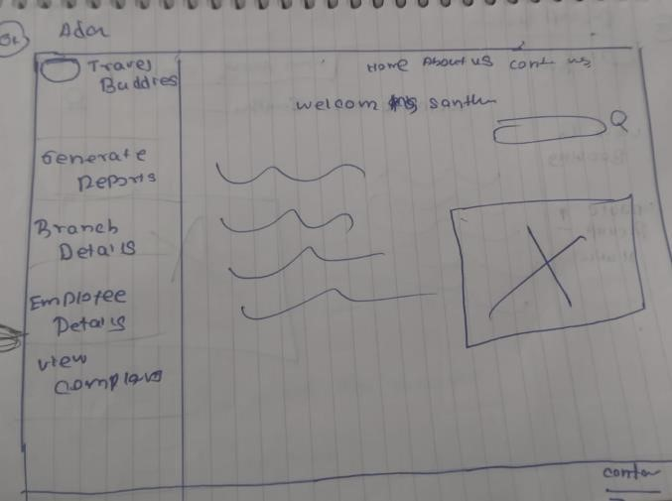

*Figure 20 Admin sketch*

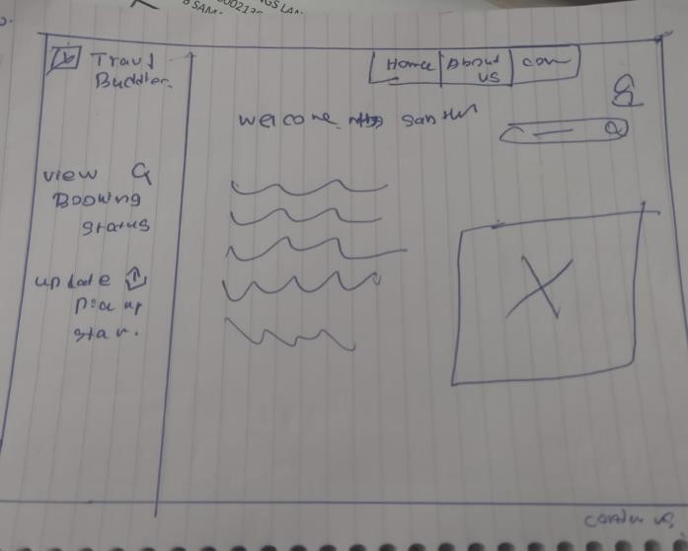

*Figure 21 pickup staff sketch*

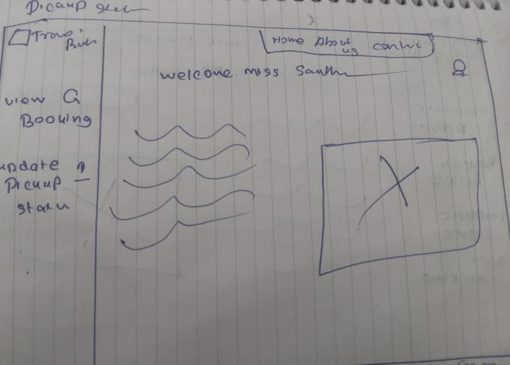

*Figure 22 Delivery Staff*

### 3.2 WireFrames, explain the phases of the designing.

WireFrames

A wireframe is a two-dimensional skeletal outline of a webpage or app. Wireframes provide a clear overview of the page structure, layout, information architecture, user flow, functionality, and intended behaviors. Styling, color, graphics, and other design elements are kept to a minimum.

They can be drawn by hand or created digitally, depending on how much detail is required.

Wireframing is a practice most commonly used by UX designers. This process allows all stakeholders to agree on where the information will be placed before the developers build the interface out with code. (Hannah, 2024)

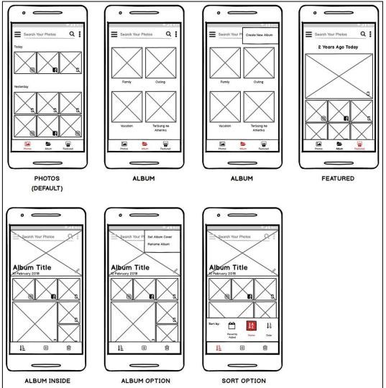

*Figure 23 Wireframes*

##### Features of Wireframe

Layout and Structure

Grid Layout: The overall layout, including columns and rows, is defined to ensure consistent alignment.

Sections and Content Blocks: Clearly delineate different sections of the page, such as header, footer, sidebar, and main content area.

Navigation Elements

Menus: The main navigation menu, often incorporating dropdowns or hamburger menus, is the main item on the screen.

Links and Buttons: Indicates where clickable elements like buttons and links will be placed

###### Advantages and Disadvantages of Wireframe

|  |  |
| --- | --- |
| **Advantages** | **Disadvantages** |
| Clarity and Focus: Wireframes offer a concise and effective representation of a project's layout and structure, focusing on functionality and user experience without obstructing design elements. | Lack of Detail: Wireframes do not incorporate design components like as colors, fonts, and graphics, making it difficult for stakeholders to see the finished result. |
| Efficiency: Wireframes are faster, less resource-intensive, and allow for rapid iteration and refinement, saving time and money on reworking complex designs. | Not Fully Representative: Wireframes may oversimplify the design, removing important elements like as interaction and animation that are required for the ultimate user experience. |
| Improved Communication: Wireframes are a crucial tool for designers, developers, and stakeholders, enabling clearer and more effective communication. | Limited Interaction: They often do not account for interactive elements, which can be crucial for understanding the functionality of the final product. |
| Focus on User Experience: Wireframes enhance user experience, ensuring intuitive products. They aid in early usability testing, gathering feedback on layout and navigation, which informs later design stages. | Changing Requirements: As wireframes are refined and iterated upon, there is a risk that project scope might expand beyond the original plan, leading to potential delays and increased costs. |
| Requirement Clarification: They help in clearly defining the requirements and functionalities, reducing misunderstandings and miscommunications. | Feature Overload: Stakeholders might continuously add new features during the wireframing stage, complicating the design process and leading to feature creep. |

*Table 17Advantages and Disadvantages of Wireframe*

**Wireframing Tools**

##### Balsamiq

Balsamiq is a rapid wireframing tool. It creates mockups and wireframes for websites, web apps, and desktop software. It allows you to picture ideas and concepts through a simple drag-and-drop interface. The wireframes created using Balsamiq have a hand-drawn style. It focuses on the structure and content of the product rather than visual details.

The main goal of Balsamiq is to facilitate effective communication between teams about user interface design. It encourages discussion and feedback on early designs before developers start coding the product. Balsamiq simplifies the process of turning ideas and concepts into concrete wireframes that represent the page structure, layouts, and interface elements. You might be wondering if it is a free tool. So, the Balsamiq desktop doesn’t need an Internet connection to save data locally on your PC. A 30-day trial of the app that is fully functioning is included. You’ll then need to purchase a license to edit your work. (paat, 2024)

**Features:** Balsamiq is a user-friendly wireframing tool for creating low-fidelity mockups of software applications, websites, and mobile apps. It features a drag-and-drop interface, pre-built UI elements, and a distinctive hand-drawn style. It supports real-time collaboration, export options like PNG, PDF, and interactive prototypes, and integrates with tools like Confluence, Jira, Google Drive, and Slack for broader project workflows. Balsamiq is an essential tool for early-stage design and prototyping.

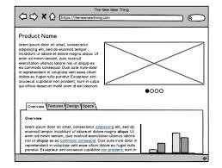

*Figure 241)Balsamiq*

##### MockFlow

MockFlow is a powerful and user-friendly tool for wireframing, enabling you to easily visualize your ideas and take them from low to high fidelity with zero learning curve. The intuitive editor simplifies the design process, and the extensive collection of UI packs and templates available in the MockStore provides a quick and easy way to kickstart your work. MockFlow doesn't just stop at wireframing, however. It offers a comprehensive end-to-end solution for the entire product design process, streamlining the workflow from conception to delivery. With additional inbuilt tools available, you can create site maps, build user profiles with User Persona, and define brand guidelines with Style Guides, all in one place.

**Features:** MockFlow is a powerful and versatile wireframing and prototyping tool designed to streamline the design process for web and mobile applications. One of its standout features is its drag-and-drop interface, which allows users to effortlessly create detailed wireframes by selecting and positioning pre-built UI components. This ease of use is enhanced by a comprehensive library of UI elements and templates, covering a wide range of design needs, from basic buttons and forms to complex navigation bars and grids. This extensive library enables designers to quickly assemble layouts and iterate on their designs without having to start from scratch.

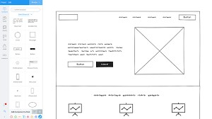

##### Axure RP

Axure RP is a leading wireframing and prototyping software that allows designers, developers, and product managers to create detailed wireframes, mockups, and prototypes. With its powerful features and easy-to-use interface, Axure simplifies the process of designing interactive and responsive web and mobile applications.

Axure RP is compatible with Windows and macOS, and users can easily collaborate on projects through the Axure Cloud platform. Additionally, the software offers various functionalities, including drag-and-drop widgets, dynamic panels, animations, and conditional logic, thus easing the process of developing and validating complex design concepts. (Riva, 2024)

##### Features of Axure RP

Interactive Prototypes

Develop dynamic prototypes showcasing real user interactions, using conditional logic to display various scenarios, and incorporate animations and transitions for a more realistic experience.

Wireframing

Create wireframes rapidly using a built-in widget library. Customize components with multiple styles, colors, and fonts to meet design needs. Create reusable components and templates to ensure uniformity across the project.

Collaboration

Multiple team members can work on a project simultaneously with version control, and stakeholders can leave comments on prototypes, share them, or publish them to Axure Cloud.

Documentation and Specifications

Create detailed specifications and documentation from prototypes, include notes and annotations to explain design decisions, and link to external resources for additional context.

#### 3.2.1 Wireframe for the provided scenario

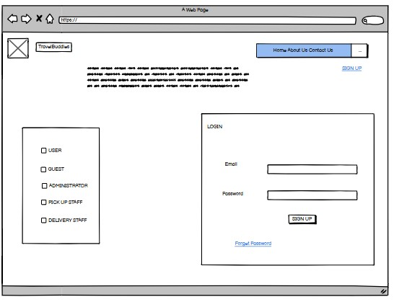

*Figure 25 login wireframe*

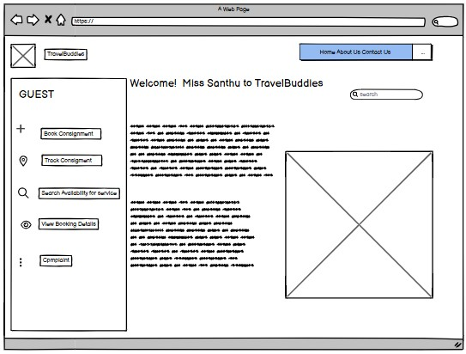

*Figure 26 guest wireframe*

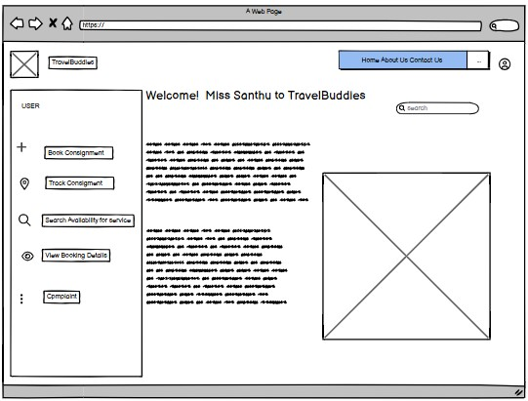

*Figure 27 user wireframe*

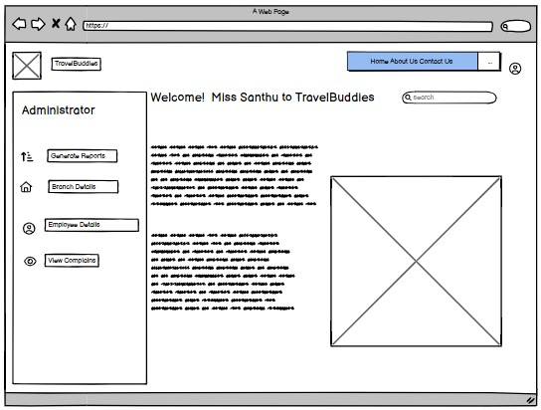

*Figure 28 Admin wireframe*

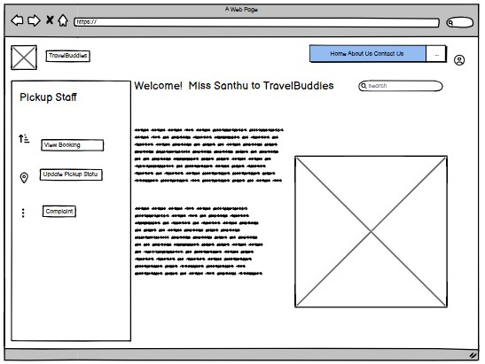

*Figure 29pickup staff wireframe*

### 3.3 Interface

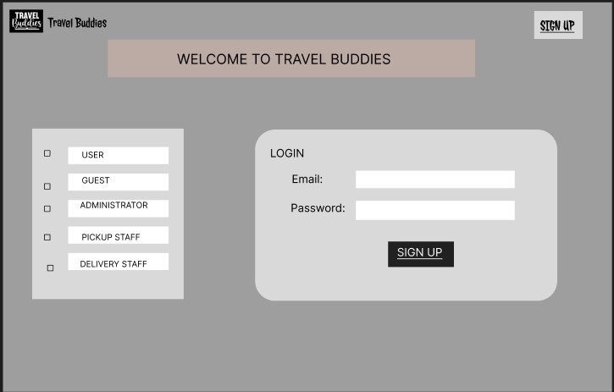

*Figure 30 Login Interface*

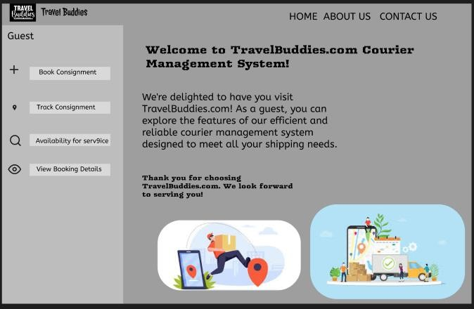

*Figure 31 Guest Interface*

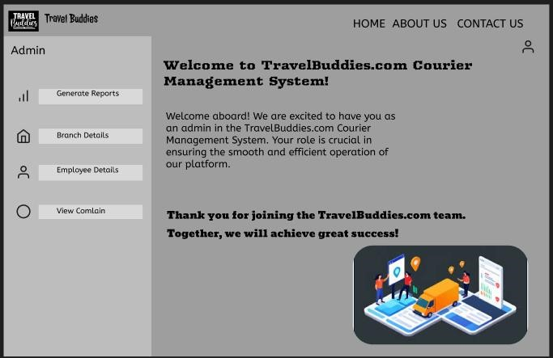

*Figure 32 Admin Interface*

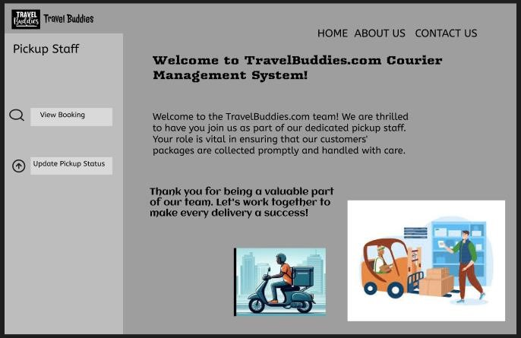

*Figure 33 Pickup Staff Interface*

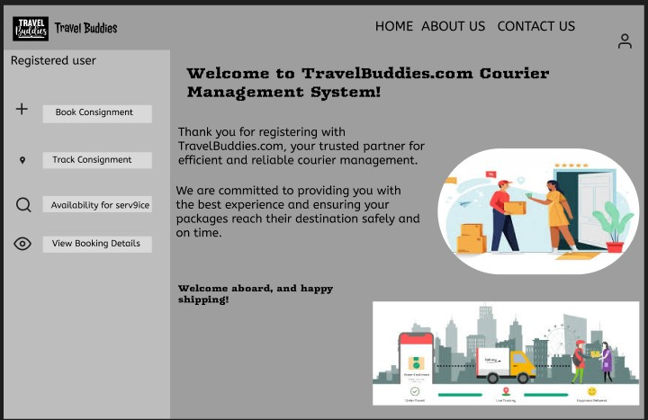

*Figure 34 Registered user Interface*

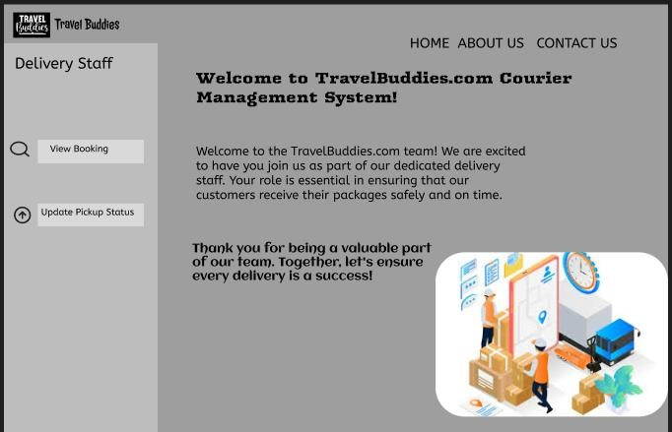

*Figure 35 Delivery staff Interface*

### 3.4 Conduct a user experiment and collect feedback

The developed interface is an initial version, and moderate usability testing is an effective way to gather user feedback. This approach allows the UX developer to create a questionnaire focused on the areas related to the system that need evaluation. Metrics can be employed to measure various aspects of the user experience. Additionally, providing users with a questionnaire is an ideal method to obtain direct feedback, and carefully considering their responses is crucial. The following is a sample feedback of a test performed using Twenty users.

3.4.1 Interface (1st Iteration)



*Figure 36 Interface (1st Iteration) 01*



*Figure 37Interface (1st Iteration) 02*



*Figure 38 Interface (1st Iteration) 03*



*Figure 39 Interface (1st Iteration) 04*



*Figure 40 Interface (1st Iteration) 05*



*Figure 41 Interface (1st Iteration) 06*

3.4.2 Feedback – first iteration

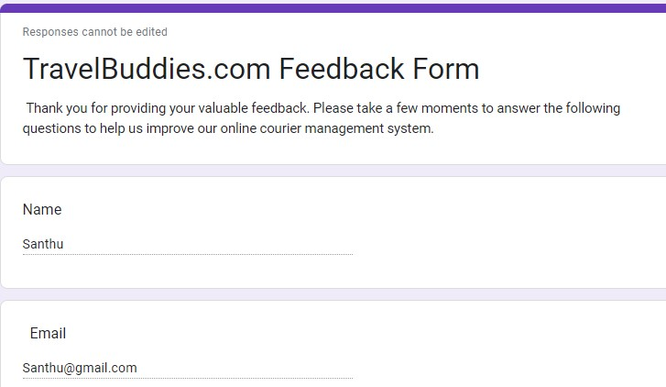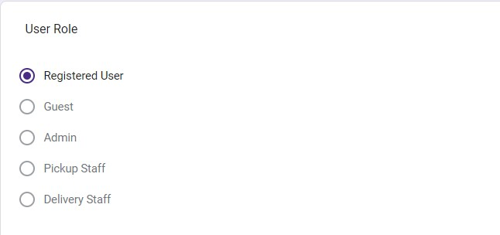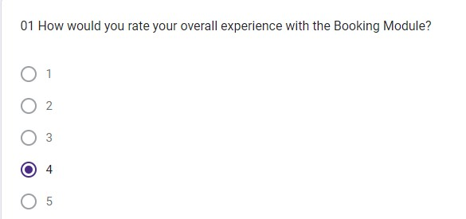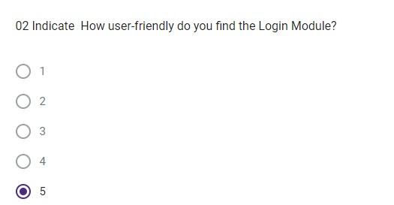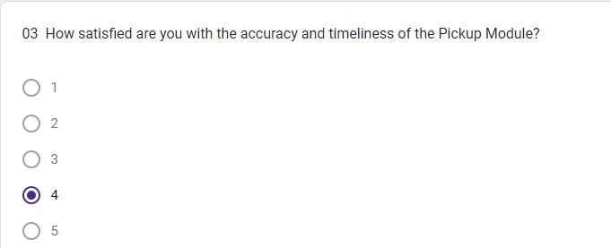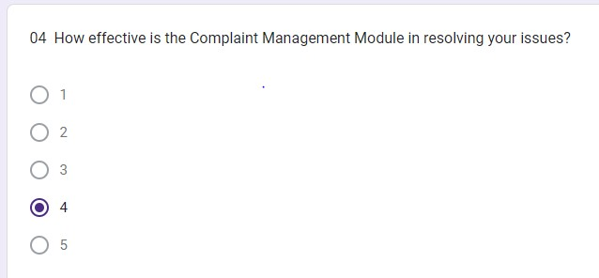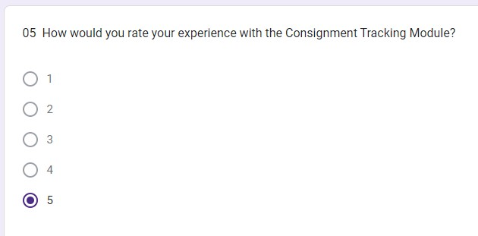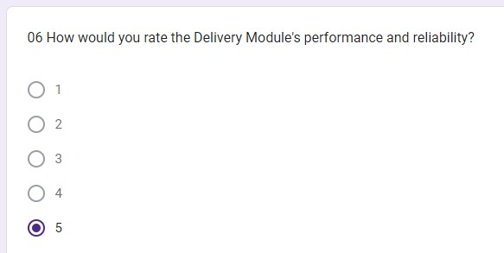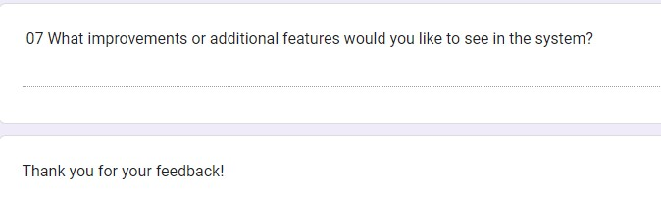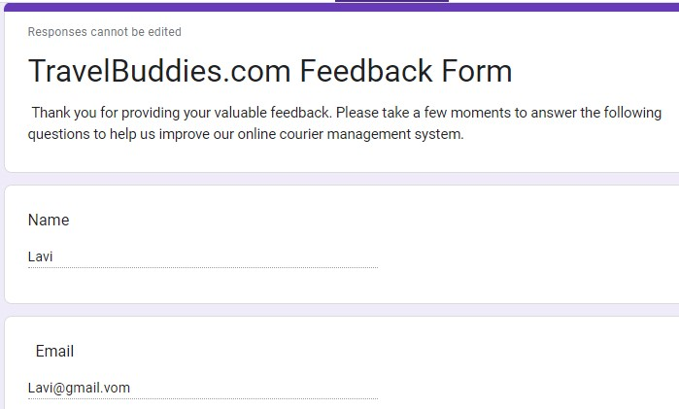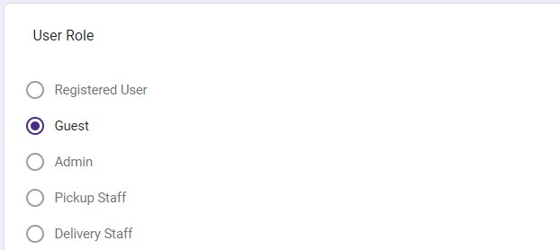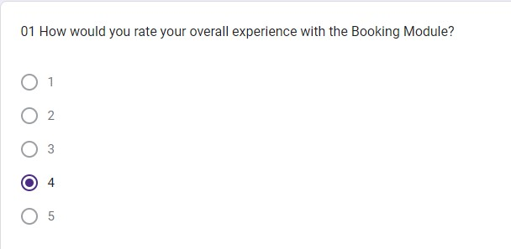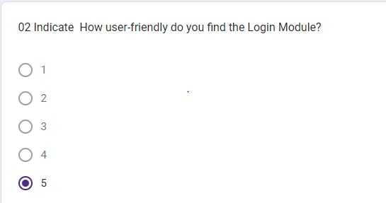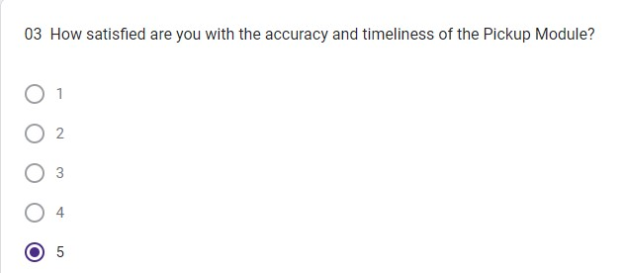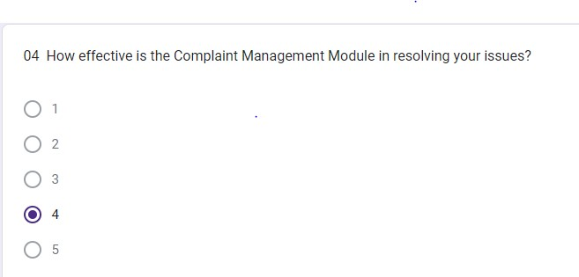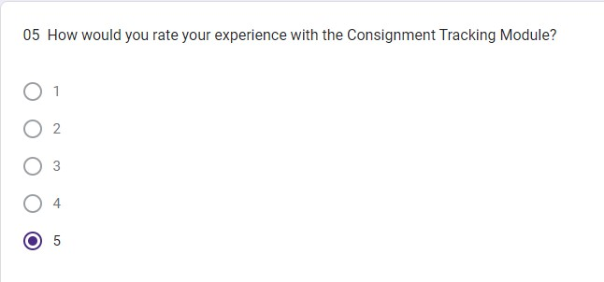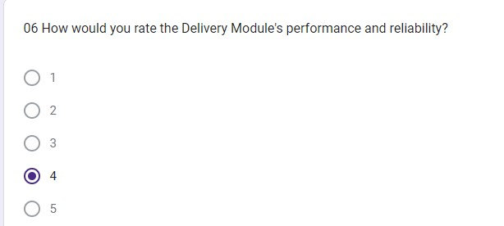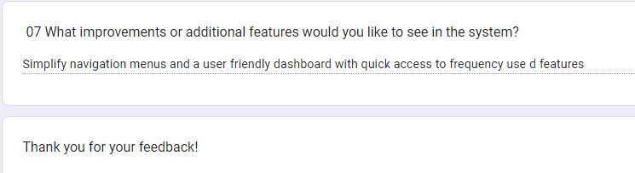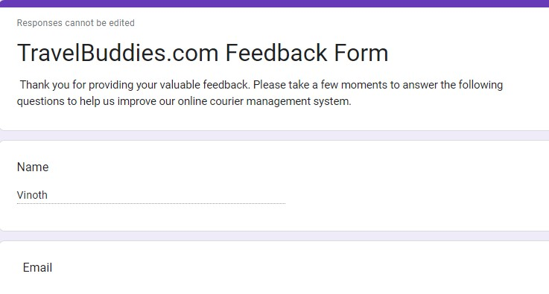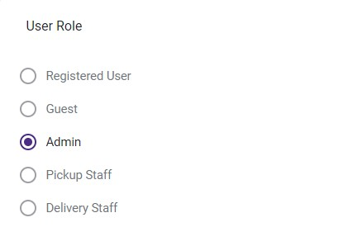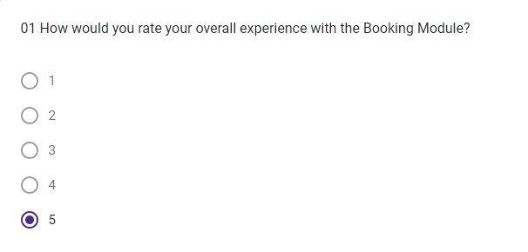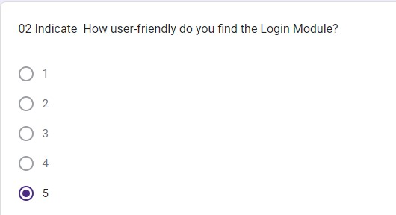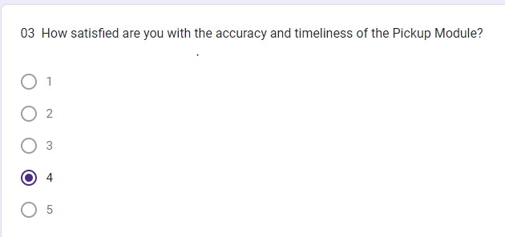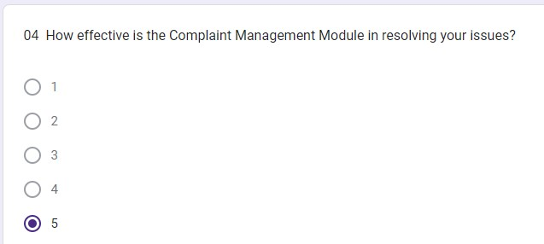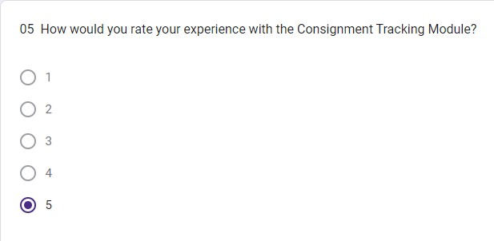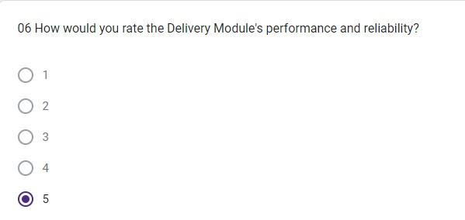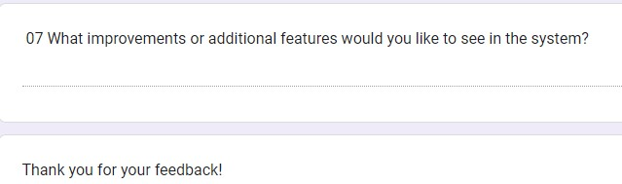

3.4.3 Feedback analysis (1st Iteration)

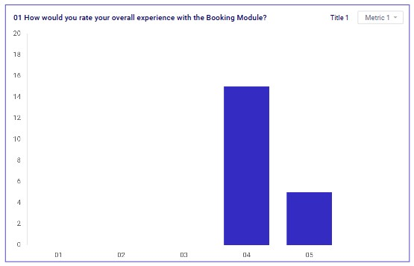

*Figure 42 Feedback analysis (1st Iteration)*

Based on the responses gathered from the end users regarding the question "How would you rate your overall experience with the Booking Module?", the feedback can be summarized as follows, 14 users rated their experience with the Booking Module as "bad". This indicates that a significant portion of users encountered issues or were dissatisfied with various aspects of the module. Their concerns could range from usability problems, technical glitches, slow performance, or an overall lack of satisfaction with the booking process.

Six users rated their experience with the Booking Module as "very bad". This indicates a severe level of dissatisfaction among these users. They likely experienced critical issues that severely impacted their ability to use the module effectively. These could include frequent crashes, inability to complete bookings, confusing interface, or other major hurdles that led to a highly negative experience.

In total, 20 users expressed negative feedback, highlighting a pressing need to investigate and address the underlying issues within the Booking Module to improve user satisfaction and functionality.

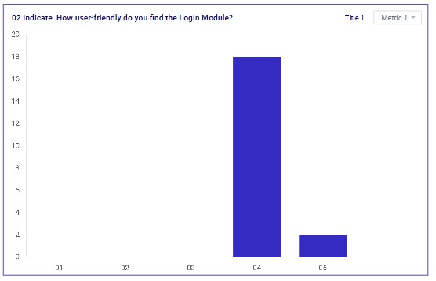

*Figure 43 Feedback analysis (1st Iteration) 02*

Based on the responses gathered from the end users regarding the question "How user-friendly do you find the Login Module?", the feedback can be summarized as follows:

Eighteen users rated the user-friendliness of the Login Module as "bad". This indicates that a majority of users faced significant challenges when interacting with the Login Module. Their concerns might include difficulties in navigating the login process, complex or unclear instructions, problems with password management or recovery, technical issues, or other obstacles that make the login experience frustrating and cumbersome.

Two users rated the user-friendliness of the Login Module as "very good". This suggests that a small number of users found the module to be easy to use, intuitive, and efficient. These users likely experienced a smooth and hassle-free login process, appreciating features such as a simple interface, quick access, and reliable performance.

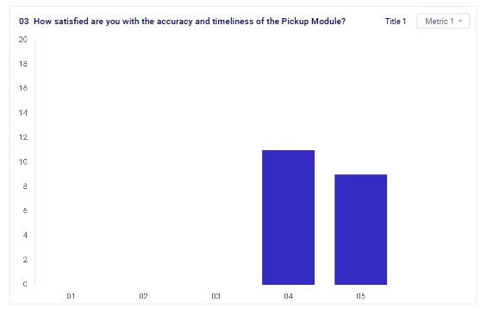

*Figure 44 Feedback analysis (1st Iteration) 03*

Eleven users rated their satisfaction with the accuracy and timeliness of the Pickup Module as "bad". This indicates that these users encountered significant issues that affected their overall experience. Problems may include inaccurate pickup times, delays in pickups, lack of real-time updates, or discrepancies between scheduled and actual pickup times. Such issues could lead to inconvenience, frustration, and a lack of trust in the module's reliability.

Nine users rated their satisfaction with the accuracy and timeliness of the Pickup Module as "very bad". This suggests that these users found the module to be reliable, with accurate pickup times and timely updates. These users likely experienced a smooth and efficient process, with pickups occurring as scheduled and real-time information being accurate and helpful.

In total, 20 users provided feedback on the Pickup Module, with a fairly even split between dissatisfaction and high satisfaction. While 11 users expressed concerns about the accuracy and timeliness, 9 users were very pleased with these aspects. This mixed feedback highlights the need for targeted improvements to address the issues faced by dissatisfied users while maintaining the elements that are working well for those who are satisfied.

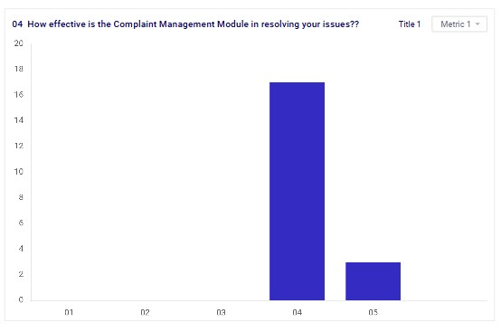

*Figure 45 Feedback analysis (1st Iteration) 05*

The Complaint Management Module's effectiveness in resolving issues appears to be notably inadequate based on the feedback collected from end users. Out of the total responses, a significant majority, 17 users, rated the module as "bad." This suggests that the module consistently fails to meet the expectations of a substantial portion of the users. Additionally, 3 users rated the module as "very bad," indicating a severe dissatisfaction with its performance. These ratings reflect a critical need for improvement in the module to better address and resolve user complaints effectively.

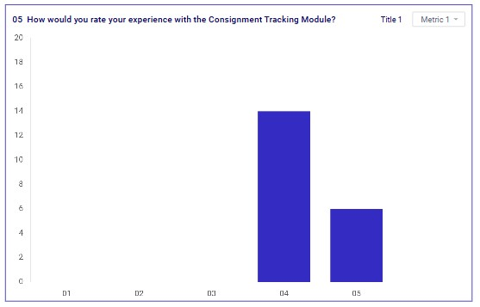

*Figure 46 Feedback analysis (1st Iteration) 05*

Fourteen users rated their experience with the Consignment Tracking Module as "bad". This suggests that a significant portion of users encountered issues or were dissatisfied with various aspects of the module. Common complaints may include inaccuracies in tracking information, delays in updates, difficulty in locating consignments, or a confusing interface that hindered effective tracking. Such issues can lead to frustration and dissatisfaction with the reliability and usability of the module.

Six users rated their experience with the Consignment Tracking Module as "very good". This indicates that a smaller number of users had a positive experience with the module. They likely found the tracking information to be accurate, updates timely, and the overall tracking process efficient and userfriendly. These users appreciated the module's effectiveness in providing them with the necessary information to track their consignments seamlessly.

In total, 20 users provided feedback on the Consignment Tracking Module, with a notable majority expressing dissatisfaction. This feedback underscores the need to address the concerns raised by users who found the module challenging or unreliable, while also recognizing the positive experiences of those who found it effective. Improving the Consignment Tracking Module could enhance user satisfaction by ensuring accurate, timely, and user-friendly tracking capabilities.

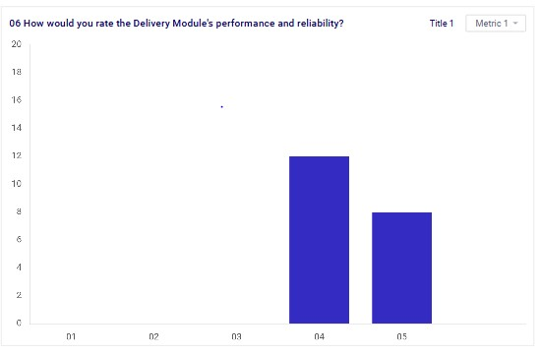

*Figure 47 Feedback analysis (1st Iteration) 06*

The feedback on the performance and reliability of the Delivery Module reveals significant user dissatisfaction. Out of the responses collected, 12 users rated their experience as bad. This indicates that a substantial portion of users encountered recurring issues that negatively impacted their perception of the module. These issues may have included problems with delivery accuracy, delays, or reliability concerns, making the delivery process frustrating and unreliable.

Additionally, 8 users rated their experience with the Delivery Module as very bad. This further underscores severe dissatisfaction, suggesting that these users faced critical and frequent failures in the module’s performance. Such negative experiences likely involved significant delays, incorrect deliveries, or other major issues that severely disrupted the intended functionality.

Overall, the majority of users expressed dissatisfaction with the Delivery Module's performance and reliability, highlighting a pressing need for substantial improvements to address these critical user concerns and enhance the module’s efficiency and dependability.

3.4.4 Interface (2nd Iteration)

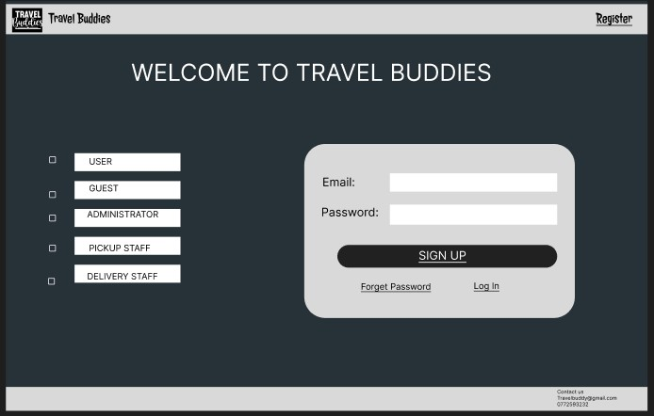

*Figure 48 Interface (2nd Iteration) 01*

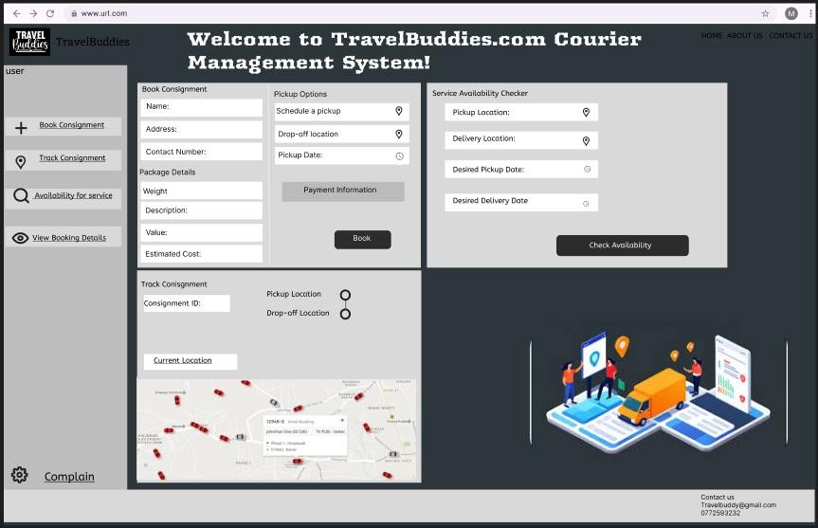

*Figure 49 Interface (2nd Iteration) 02*

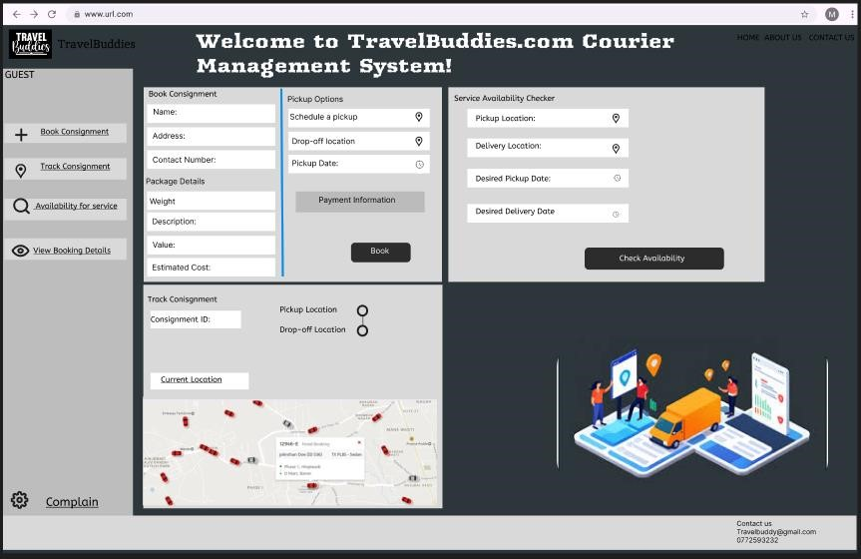

*Figure 50 Interface (2nd Iteration) 03*

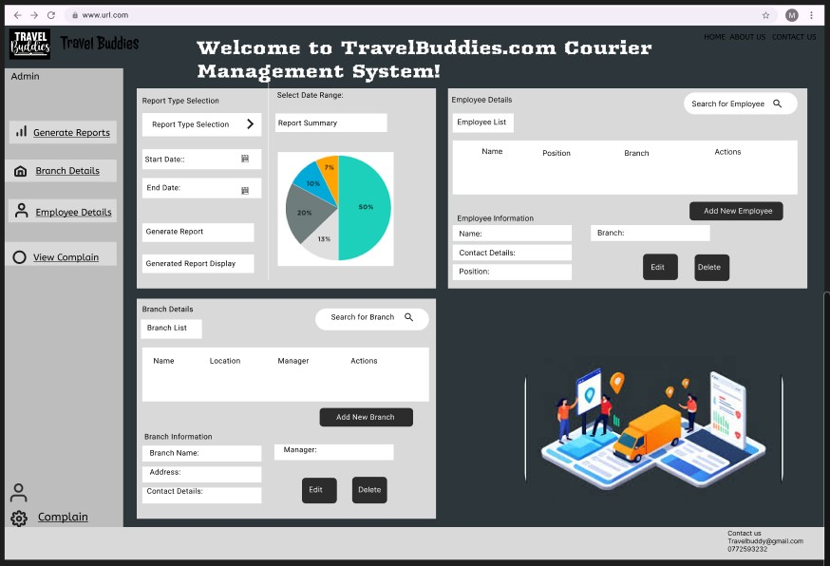

*Figure 51 Interface (2nd Iteration) 04*

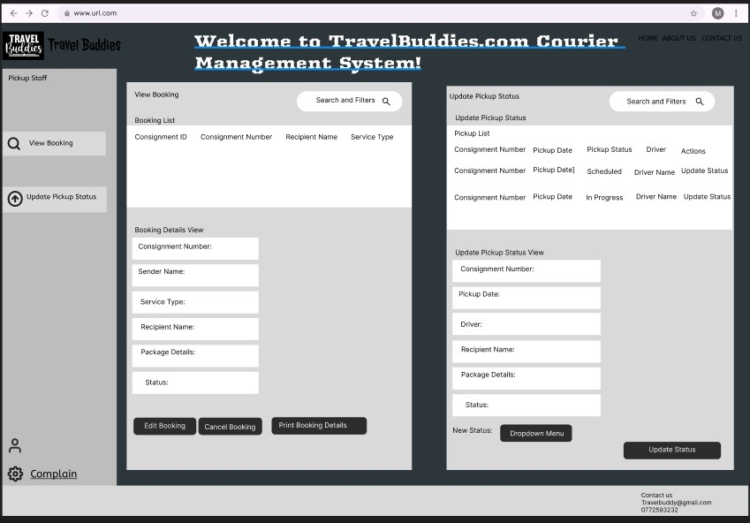

*Figure 52 Interface (2nd Iteration) 05*

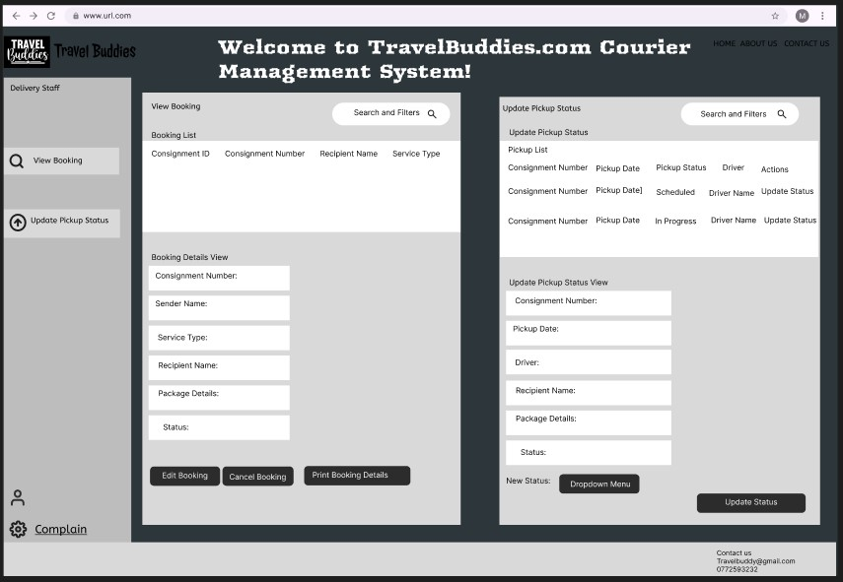

*Figure 53 Interface (2nd Iteration) 06*

3.4.5 Feedback Form-Second Iteration

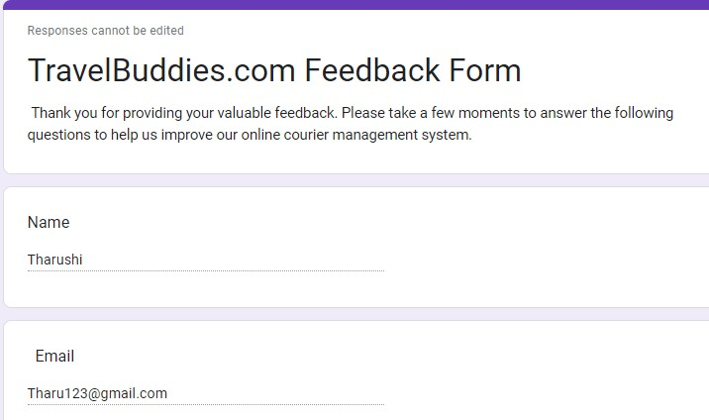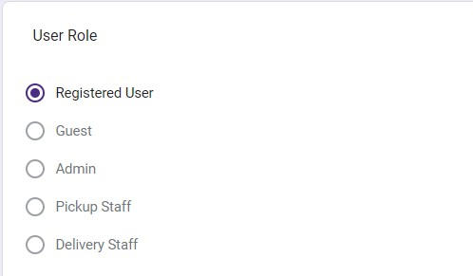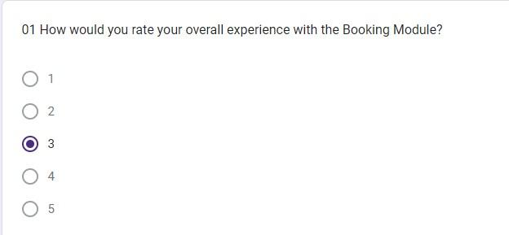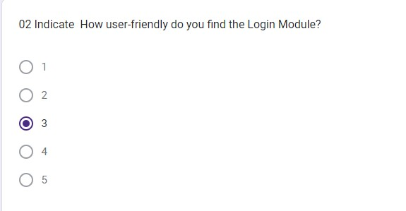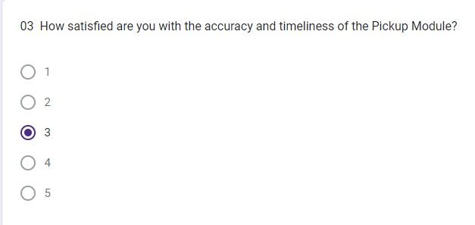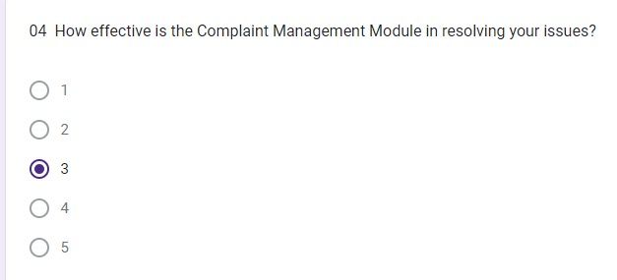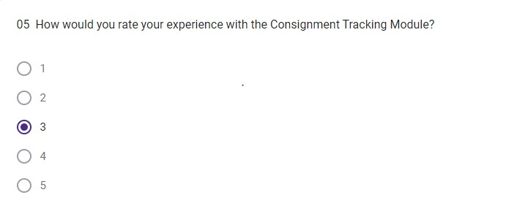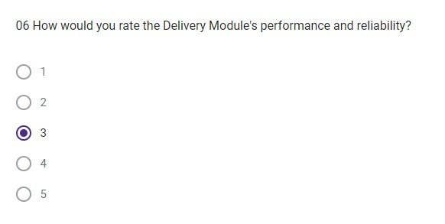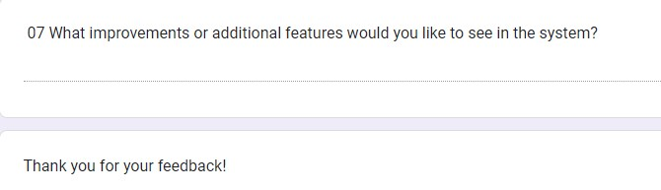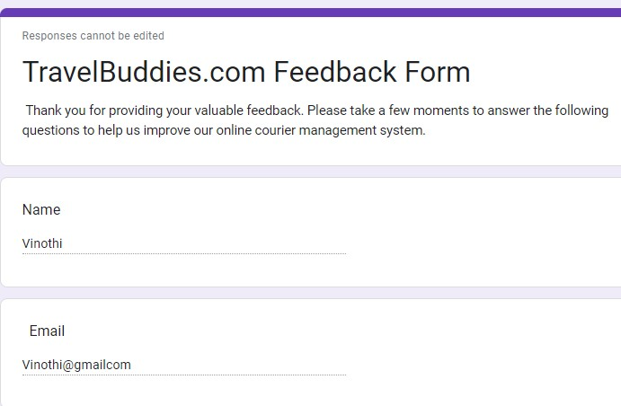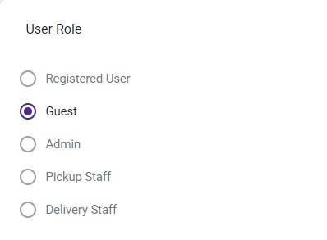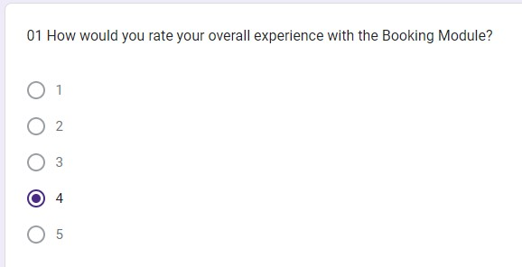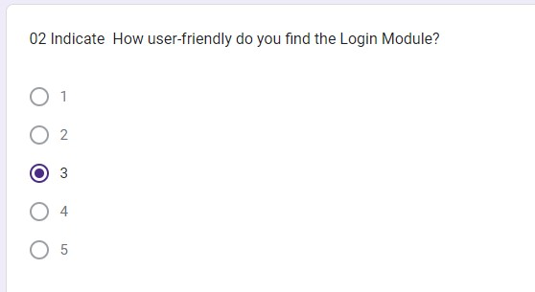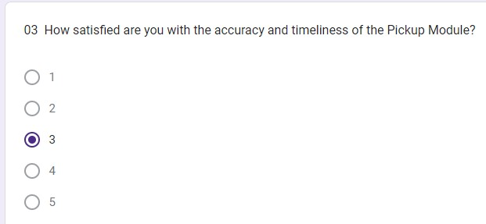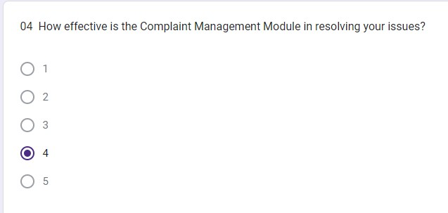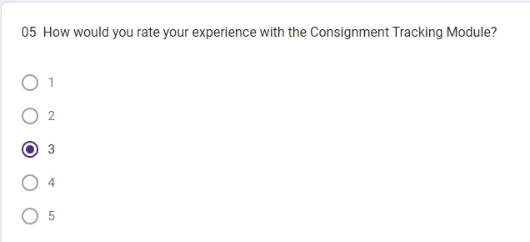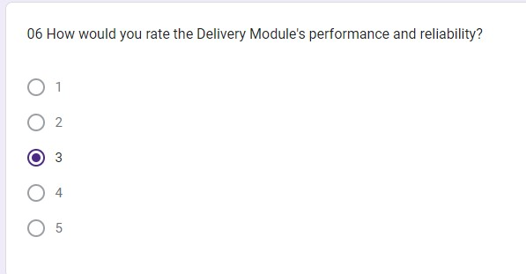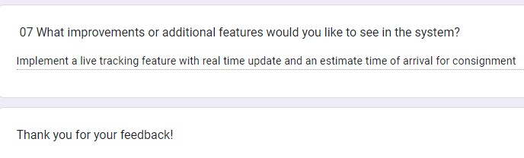

3.4.6 Feedback Analysis (2nd Iteration)

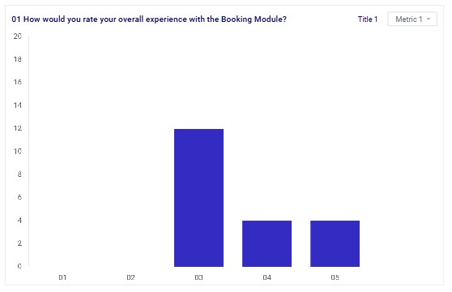

*Figure 54 Feedback Analysis (2nd Iteration) 01*

Following the second iteration of feedback collected from twenty Travel Buddies Courier Management System users, responses regarding the Booking Module varied. Twelve users rated their overall experience as Neutral, indicating a lack of strong positive or negative sentiment. However, a notable proportion expressed dissatisfaction, with four users rating their experience as Bad, and an additional four rating it as Very Bad. These insights highlight specific areas where the Booking Module may fall short of user expectations. Issues such as usability challenges, unclear interface design, or functionality limitations could contribute to this dissatisfaction. Addressing these concerns effectively in subsequent development phases will be essential to improving user satisfaction and ensuring a more efficient booking experience within the Travel Buddies Courier Management System.

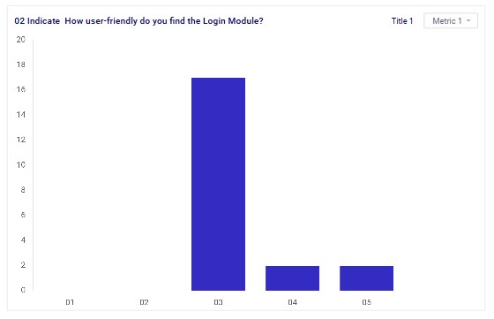

*Figure 55 Feedback Analysis (2nd Iteration) 02*

Based on the feedback received from the end users regarding the Login Module, the detailed description of their responses is as follows:

Neutral: A majority of 16 users rated their experience with the Login Module as neutral. This suggests that while they did not find significant issues with the functionality, they also did not find it particularly outstanding or noteworthy. The experience was average, meeting their basic expectations without impressing them.

Bad: 2 users reported their experience with the Login Module as bad. This indicates dissatisfaction with certain aspects of the module. These users likely encountered issues that hindered their overall experience, making it less user-friendly and possibly frustrating.

Very Bad: Although the exact count is not mentioned, the presence of this category suggests that some users experienced severe issues with the Login Module. These issues could be related to difficulties in accessing their accounts, navigation problems, or other critical usability flaws that significantly impacted their experience.

Overall, the feedback indicates that while most users found the Login Module to be acceptable or neutral, there are notable areas for improvement to address the concerns of those who had negative experiences.

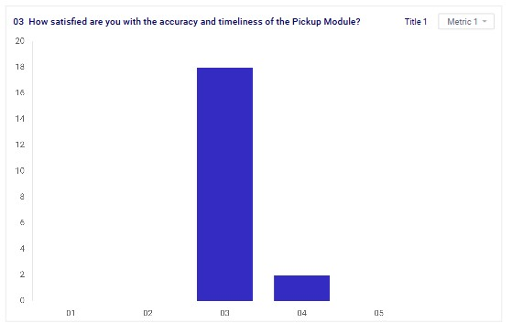

*Figure 56 Feedback Analysis (2nd Iteration) 03*

Based on the feedback received from the end users regarding the accuracy and timeliness of the Pickup Module, the detailed description of their responses is as follows:

A significant number of 18 users rated their satisfaction with the Pickup Module as neutral. This suggests that these users found the accuracy and timeliness of the module to be neither exceptionally good nor particularly bad. It implies that while the module met their basic expectations, it did not stand out as particularly efficient or reliable in terms of performance.

Two users expressed dissatisfaction with the Pickup Module, rating it as bad. This indicates that these users encountered issues related to the accuracy and timeliness of the pickup process, which negatively impacted their overall experience. Problems may have included incorrect information, delays, or other issues that hindered the reliability of the module.

Overall, the feedback suggests that while the majority of users found the Pickup Module to be adequate, there are areas for improvement to enhance its accuracy and timeliness to better meet user expectations and address the concerns of those who were dissatisfied.

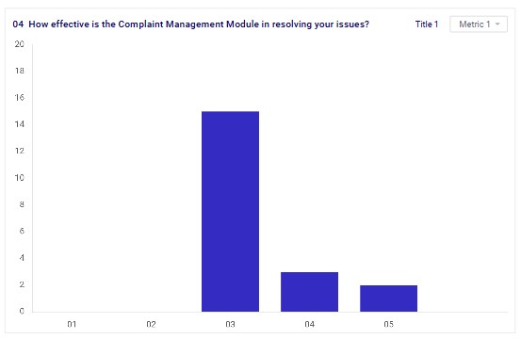

*Figure 57 Feedback Analysis (2nd Iteration) 04*

The feedback on the effectiveness of the Complaint Management Module in resolving user issues highlights a mixed but generally unfavorable sentiment. Out of the responses collected, 15 users rated their experience as neutral. This indicates that while the module was functional, it did not stand out as particularly effective or efficient in addressing user complaints. These users likely experienced a basic level of service that met minimum expectations without providing notable resolutions or satisfaction.

Additionally, 3 users rated their experience with the Complaint Management Module as bad, reflecting dissatisfaction with the module’s performance. These users probably encountered difficulties in having their issues resolved, such as slow response times, ineffective solutions, or a lack of clear communication, leading to a negative overall experience.

Furthermore, 2 users rated their experience as very bad, indicating severe dissatisfaction. These users likely faced significant challenges, such as unresolved complaints, poor customer service, or a lack of responsiveness, which severely impacted their perception of the module’s effectiveness.

Overall, the majority of users did not find the Complaint Management Module to be particularly effective, with a notable portion expressing dissatisfaction. This feedback suggests a need for improvements in the module’s responsiveness, communication, and resolution processes to better meet user expectations and enhance overall satisfaction.

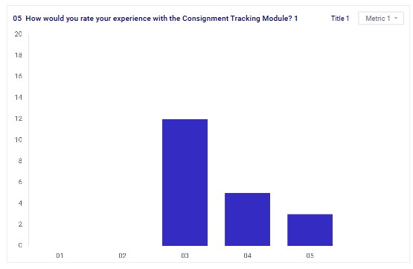

*Figure 58 Feedback Analysis (2nd Iteration) 05*

The feedback on the Consignment Tracking Module reveals a generally unfavorable user experience. Out of the responses collected, 12 users rated their experience as neutral. This indicates that while the module provided basic functionality, it did not significantly impress or satisfy users. These users likely found the tracking process adequate but lacking in features, reliability, or user-friendliness that could have enhanced their experience.

Moreover, 5 users rated their experience with the Consignment Tracking Module as bad. This reflects dissatisfaction with the module’s performance, suggesting that these users encountered issues such as inaccuracies in tracking information, delays in updates, or difficulties navigating the system, which hindered their ability to effectively track their consignments.

Furthermore, 3 users rated their experience as very bad, indicating severe dissatisfaction. These users likely faced major challenges such as frequent errors, outdated information, or a completely unreliable tracking system, leading to significant frustration and a negative perception of the module.

Overall, the feedback indicates that while a portion of users found the Consignment Tracking Module to be merely adequate, a significant number experienced dissatisfaction, highlighting the need for improvements in accuracy, reliability, and user interface to better meet user expectations and enhance overall satisfaction.

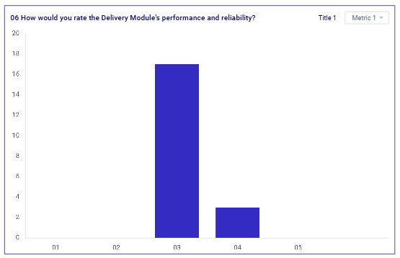

*Figure 59 Feedback Analysis (2nd Iteration) 06*

Based on the feedback from end users regarding the Delivery Module's performance and reliability, the majority of responses indicate a mixed but generally lukewarm sentiment. Specifically, 17 users rated their experience as neutral, suggesting that while the Delivery Module functioned adequately, it did not exceed expectations or deliver a particularly standout performance. Users in this category likely encountered acceptable but unremarkable service, with deliveries being generally on time but perhaps lacking in additional reliability measures or features that could enhance user satisfaction.

Additionally, 3 users rated their experience with the Delivery Module as bad. This indicates a level of dissatisfaction among these users, who likely experienced notable issues such as delays, inaccuracies in delivery times, or inconsistent service quality. Such problems could have led to frustration and a diminished perception of the module's reliability.

Overall, while the majority of users found the Delivery Module to be acceptable in terms of performance and reliability, there is a clear indication from a minority of users that improvements are needed to address issues and enhance overall user satisfaction. These improvements could focus on ensuring more consistent and reliable delivery services, improving communication about delivery statuses, and addressing any operational shortcomings that users have identified.

3.4.7 Interface (3rd Iteration)

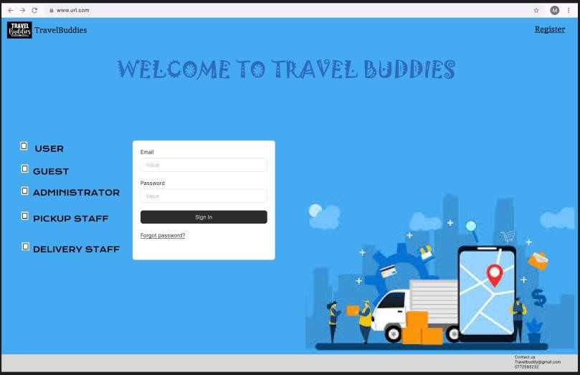

*Figure 60 Interface (3rd Iteration) 01*

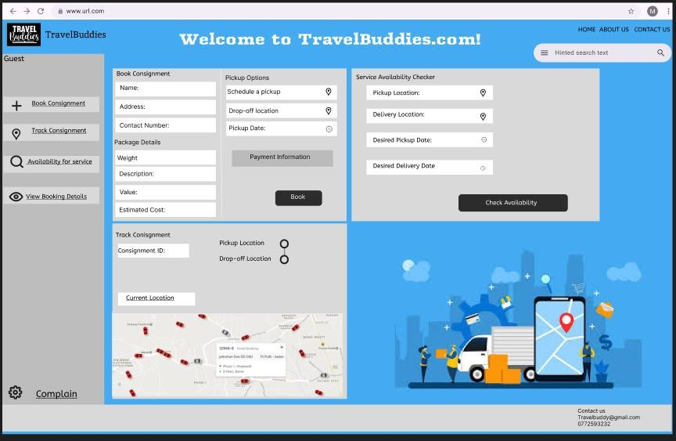

*Figure 61 Interface (3rd Iteration) 02*

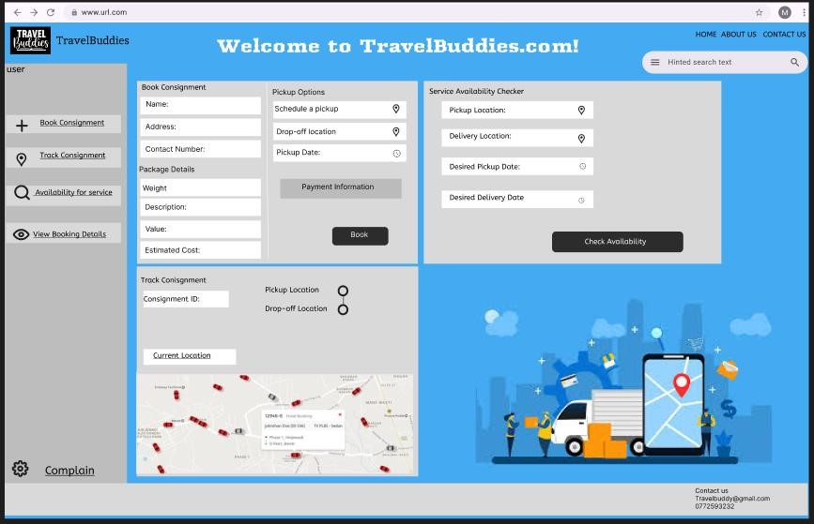

*Figure 62 Interface (3rd Iteration) 03*

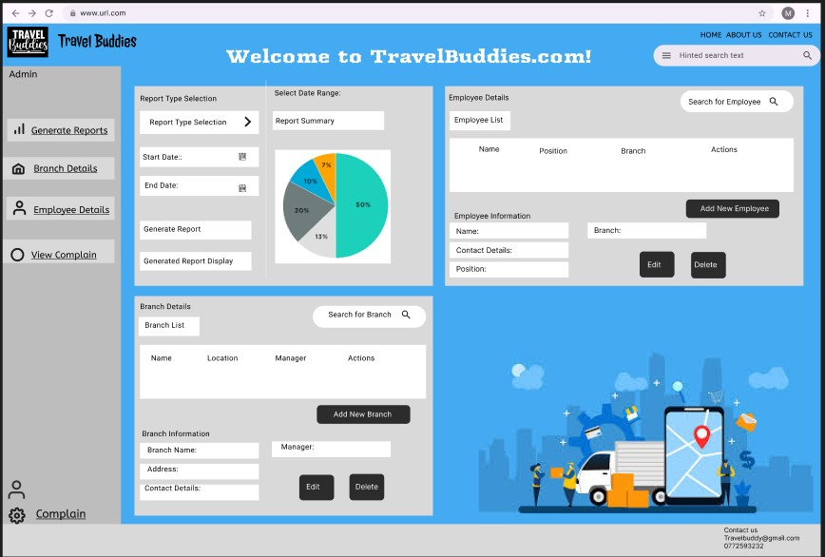

*Figure 63 Interface (3rd Iteration) 04*

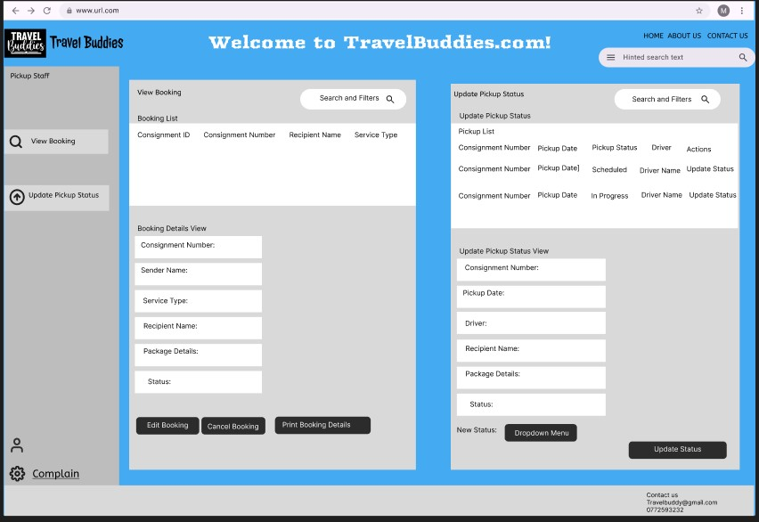

*Figure 64 Interface (3rd Iteration)05*

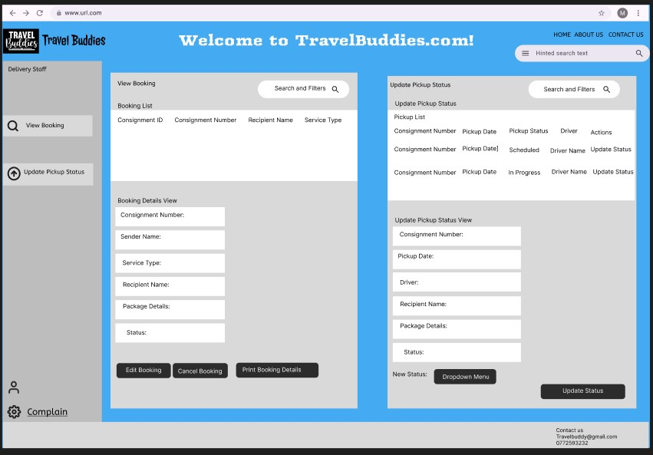

*Figure 65 Interface (3rd Iteration) 06*

3.4.8 Feedback Form – Third Iteration

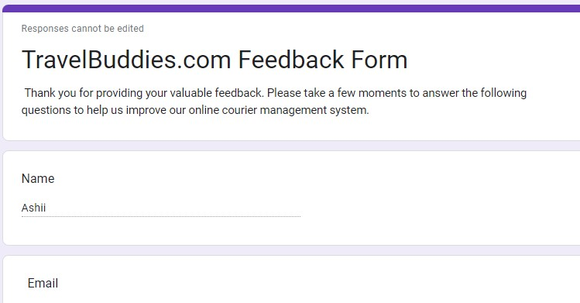

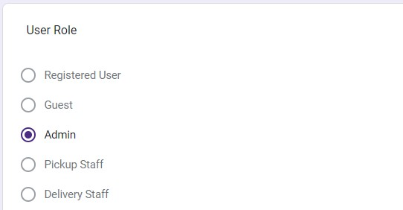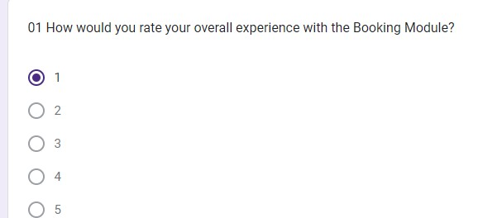

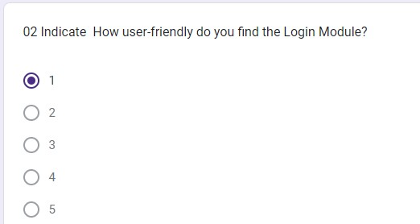

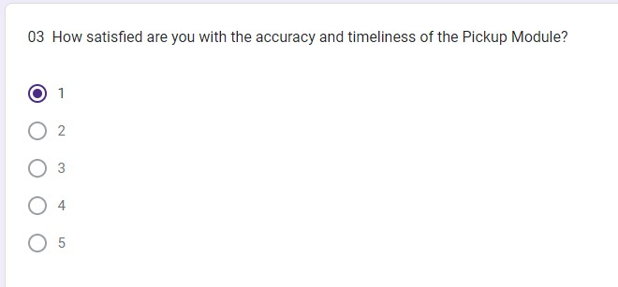

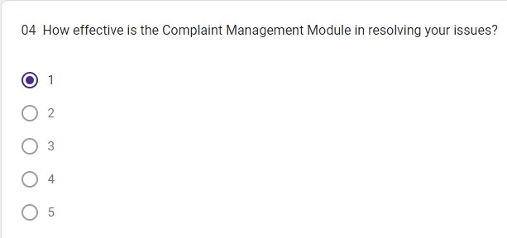

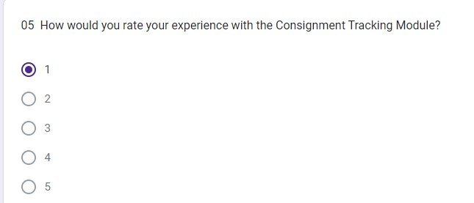

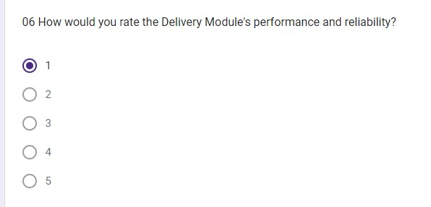

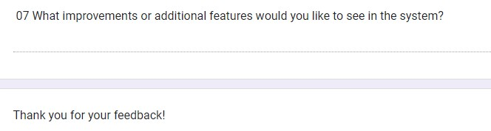

3.4.9 Feedback Analysis (3rd Iteration)

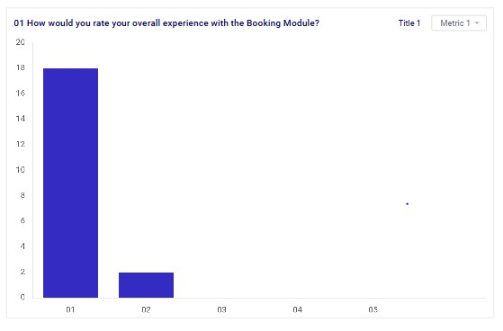

*Figure 66 Feedback Analysis (3rd Iteration) 01*

Comparing the feedback from the second and third iterations of user feedback on the Travel Buddies Courier Management System reveals a significant shift in user sentiment towards the Booking Module. Initially, from the second iteration, feedback indicated a mixed response: twelve users felt neutral about their experience, signaling a lack of strong positive or negative feelings, while a notable portion expressed dissatisfaction, with four users rating their experience as Bad and an additional four as Very Bad. Issues such as usability challenges and unclear interface design were highlighted as potential contributors to this dissatisfaction.

In contrast, following the third iteration of feedback, substantial improvements were evident. Eighteen users rated their overall experience with the Booking Module as very good, indicating a substantial increase in satisfaction due to the module's enhanced functionality and usability. An additional two users rated their experience as good, further reinforcing positive sentiment towards the improvements implemented based on previous feedback. These results underscore the effectiveness of iterative development, where direct user input has directly influenced and improved the system. The positive ratings suggest that the adjustments made have effectively addressed earlier concerns, resulting in a more streamlined and satisfactory booking experience for users of the Travel Buddies Courier Management System.

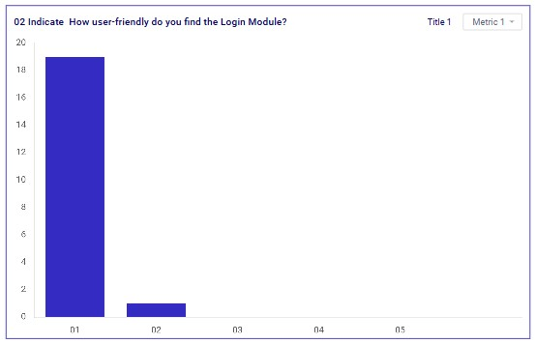

*Figure 67 Feedback Analysis (3rd Iteration) 02*

Comparing the feedback from the second and third iterations regarding the Login Module of the Travel Buddies Courier Management System reveals a notable transformation in user satisfaction. Initially, from the second iteration, feedback indicated a majority of sixteen users rated their experience as neutral, suggesting a functional but unremarkable login process that met basic expectations without standing out. Two users reported a bad experience, highlighting specific issues that detracted from usability, while the existence of a "Very Bad" category implied severe usability challenges for some users.

In contrast, following the third iteration of feedback, significant improvements were evident. Nineteen users rated the user-friendliness of the Login Module as very good, indicating a substantial increase in satisfaction due to enhancements and changes made based on previous feedback. An additional user rated it as good, reinforcing positive sentiment towards the improvements implemented. These results underscore the effectiveness of iterative development, where direct user input has directly influenced and improved the system. The overwhelmingly positive ratings suggest that the adjustments have successfully addressed earlier usability concerns, leading to a more intuitive and efficient login experience for users of the Travel Buddies Courier Management System.

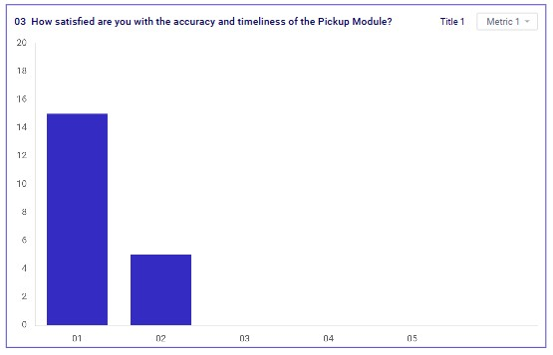

*Figure 68 Feedback Analysis (3rd Iteration) 03*

Comparing the feedback from the second and third iterations regarding the accuracy and timeliness of the Pickup Module in the Travel Buddies Courier Management System reveals notable progress in user satisfaction. Initially, from the second iteration, a significant number of eighteen users rated their satisfaction as neutral, indicating that while the module met basic expectations, it did not excel in terms of efficiency or reliability. Two users expressed dissatisfaction, rating the module as bad, and highlighting specific issues such as inaccuracies or delays that detracted from their experience.

In contrast, following the third iteration of feedback, significant improvements were evident. Fifteen users rated their satisfaction as very good, indicating a substantial increase in approval with the module's accuracy and timeliness. Additionally, five users rated their satisfaction as good, further confirming positive sentiment towards the improvements implemented based on user feedback. These results underscore the effectiveness of iterative development, where direct user input has directly influenced and improved the system. The overwhelmingly positive ratings suggest that the adjustments have successfully addressed earlier concerns, leading to a more reliable and efficient process for scheduling and executing pickups within the Travel Buddies Courier Management System.

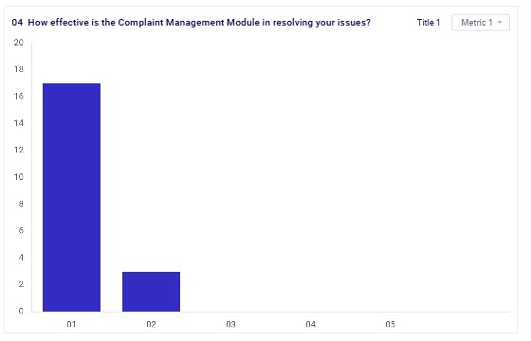

*Figure 69 Feedback Analysis (3rd Iteration) 04*

Comparing the feedback from the second and third iterations regarding the effectiveness of the Complaint Management Module in the Travel Buddies Courier Management System reveals ongoing challenges in user satisfaction. Initially, from the second iteration, feedback indicated a mixed but generally unfavorable sentiment: fifteen users rated their experience as neutral, suggesting that while the module functioned adequately, it lacked standout effectiveness in resolving complaints. Three users rated their experience as bad, citing dissatisfaction with slow response times or ineffective solutions, while two users rated it as very bad, indicating severe dissatisfaction possibly due to unresolved complaints or poor customer service.

In contrast, following the third iteration of feedback, while specific counts weren't provided, the module's effectiveness still garnered mixed reviews. The feedback highlighted ongoing issues: while seventeen users rated their experience as very good, indicating improved satisfaction with issue resolution, three users rated it as good, showing some positive sentiment. However, the presence of users who rated their experience negatively in the second iteration suggests ongoing challenges in achieving consistent effectiveness in resolving complaints. This indicates a continued need for improvements in responsiveness, communication, and resolution processes to enhance user satisfaction and meet expectations within the Travel Buddies Courier Management System

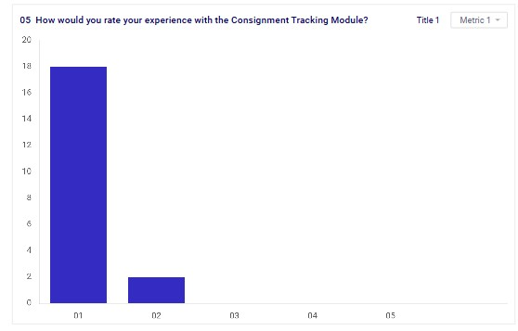

*Figure 70 Feedback Analysis (3rd Iteration) 05*

Comparing the feedback from the second and third iterations regarding the Consignment Tracking Module in the Travel Buddies Courier Management System reveals a significant improvement in user satisfaction. Initially, from the second iteration, feedback indicated a generally unfavorable experience: twelve users rated their experience as neutral, suggesting that while the module functioned adequately, it did not meet high expectations in terms of features or user-friendliness. Additionally, five users rated their experience as bad, citing issues such as inaccuracies or delays in tracking updates, which impacted their ability to monitor consignments effectively. Three users rated it as very bad, indicating severe dissatisfaction likely due to frequent errors or unreliability in the tracking system.

In contrast, following the third iteration of feedback, the Consignment Tracking Module received highly positive ratings. Eighteen users rated their experience as very good, indicating a substantial increase in satisfaction with the module's performance in tracking consignments effectively. Two users rated it as good, further confirming positive sentiment towards the improvements implemented based on user feedback. These results highlight the success of iterative development, where direct user input has directly influenced and improved the system. The overwhelmingly positive ratings suggest that the adjustments have successfully addressed earlier concerns, leading to a more reliable and satisfactory experience for users tracking consignments within the Travel Buddies Courier Management System.

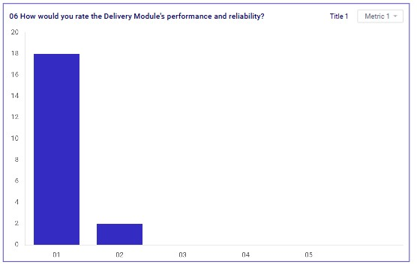

*Figure 71 Feedback Analysis (3rd Iteration) 06*

Comparing the feedback from the second and third iterations regarding the Delivery Module's performance and reliability in the Travel Buddies Courier Management System reveals a notable shift towards improved user satisfaction. Initially, from the second iteration, feedback indicated a mixed but generally lukewarm sentiment: seventeen users rated their experience as neutral, suggesting the module functioned adequately but did not exceed expectations or provide standout performance. Additionally, three users rated their experience as bad, citing issues such as delays or inaccuracies in delivery times, which impacted their perception of the module's reliability.

In contrast, following the third iteration of feedback, the Delivery Module received overwhelmingly positive ratings. Eighteen users rated it as very good, indicating a significant increase in satisfaction with its performance in delivering parcels reliably and efficiently. Two users rated it as good, further confirming positive sentiment towards the improvements implemented based on user feedback. These results highlight the success of iterative development, where direct user input has directly influenced and improved the system. The consistently positive ratings suggest that the adjustments have successfully addressed earlier concerns, leading to a more dependable and satisfactory delivery process for users within the Travel Buddies Courier Management System.

# Activity 04

## 4.1 Analyze overall feedback

#### 4.1.1 Overall Analysis on 1st iteration

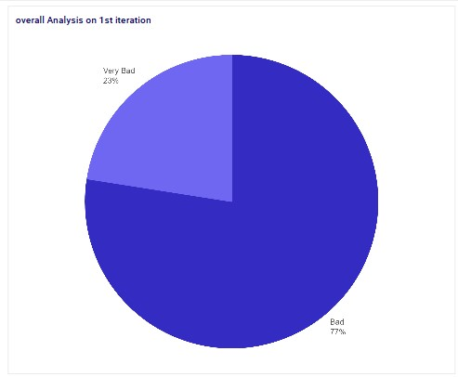

*Figure 72 4.1.1Overall Analysis on 1st iteration*

The overall feedback indicates significant user dissatisfaction across multiple modules. In the Booking Module, 14 users (70%) rated their experience as "bad," and 6 users (30%) rated it as "very bad," pointing to issues like usability problems, technical glitches, and a confusing interface. The Login Module received predominantly negative feedback, with 18 users (90%) finding it "bad" and only 2 users (10%) rating it as "very good," suggesting challenges with navigation, complex instructions, and technical difficulties. The Pickup Module had mixed reviews; 11 users (55%) rated it "bad," and 9 users (45%) rated it "very bad," indicating problems with accuracy and timeliness but also some reliability.

The Complaint Management Module was notably inadequate, with 17 users (85%) rating it as "bad" and 3 users (15%) as "very bad," highlighting its failure to meet user expectations in resolving issues. The Consignment Tracking Module also saw a significant portion of negative feedback, with 14 users (70%) rating it "bad" and 6 users (30%) rating it "very good," reflecting issues with tracking accuracy and updates. Lastly, the Delivery Module received substantial criticism, with 12 users (60%) rating it "bad" and 8 users (40%) rating it "very bad," indicating recurring problems with delivery accuracy, delays, and reliability.

In summary, the majority of users expressed dissatisfaction across these modules, pointing to various technical and usability issues that need to be addressed to improve user satisfaction and functionality.

#### 4.1.2 Overall Analysis on 2nd iteration

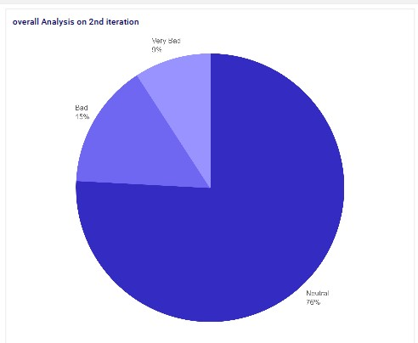

*Figure 73 Overall Analysis on 2nd iteration*

The overall feedback from users regarding the Travel Buddies Courier Management System highlights several areas needing improvement across different modules. In the second iteration of feedback, the Booking Module received a mix of neutral (12 users), bad (4 users), and very bad (4 users) ratings, pointing to issues with usability, interface design, and functionality. The Login Module saw a majority of neutral ratings (16 users), indicating that while it met basic expectations, it didn't impress. However, there were also a few users who rated it as bad or very bad, suggesting that some experienced significant issues with accessibility and usability.

For the Pickup Module, 18 users rated their satisfaction as neutral, while 2 rated it as bad. This feedback implies that while the module performed adequately, it did not excel in accuracy or timeliness. The Complaint Management Module also received mixed feedback, with 15 users rating it as neutral, 3 as bad, and 2 as very bad. This indicates that while the module was functional, it struggled to effectively resolve user complaints, leading to dissatisfaction among some users.

The Consignment Tracking Module similarly received predominantly neutral feedback (12 users), with 5 users rating it as bad and 3 as very bad. This suggests that the module provided basic functionality but faced issues with accuracy, reliability, and user-friendliness. Finally, the Delivery Module was rated as neutral by 17 users, with 3 users rating it as bad.

This indicates that while the module functioned adequately, it did not exceed expectations and had issues with delivery accuracy and consistency. Overall, the feedback reveals that while the modules generally met basic expectations, there were significant areas for improvement. Users identified issues with usability, reliability, accuracy, and the effectiveness of various modules, highlighting a need for targeted enhancements to improve user satisfaction and overall system performance.

#### 4.1.3 Overall Analysis on 3rd iteration

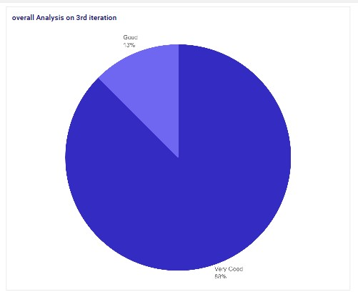

*Figure 74 4.1.3Overall Analysis on 3rd iteration*

Comparing the feedback from the second and third iterations of user feedback on the Travel Buddies Courier Management System reveals significant improvements in user satisfaction across most modules. Initially, the Booking Module had mixed responses, with many users feeling neutral and some expressing dissatisfaction due to usability challenges and unclear interface design. However, in the third iteration, there was a substantial increase in satisfaction, with the majority of users rating their experience as very good, indicating that enhancements in functionality and usability effectively addressed previous concerns. Similarly, the Login Module saw a notable transformation, moving from a largely neutral reception to overwhelmingly positive ratings, highlighting successful improvements in user-friendliness.

The Pickup Module also showed progress, with user satisfaction shifting from neutral and somewhat dissatisfied ratings to a significant majority rating their experience as very good, reflecting enhanced accuracy and timeliness. The Complaint Management Module, while showing some improvement, still faced ongoing challenges. Despite some positive ratings, the presence of negative feedback indicated the need for further enhancements in responsiveness and resolution processes.

The Consignment Tracking Module experienced a marked improvement, with initial feedback indicating a generally unfavorable experience due to inaccuracies and delays. In the third iteration, user satisfaction soared, with most users rating their experience as very good, demonstrating successful improvements in reliability and user-friendliness. Finally, the Delivery Module also saw a positive shift, moving from a lukewarm reception to overwhelmingly positive feedback, indicating that enhancements in reliability and efficiency effectively addressed earlier concerns.

Overall, the iterative development process, driven by direct user input, has significantly improved user satisfaction across most modules of the Travel Buddies Courier Management System. These improvements highlight the importance of addressing user feedback to enhance functionality, usability, and overall user experience.

## 4.2 Define how end-user feedback gathered from the multiple iterations helps the above prototype development overall.

The feedback from the three iterations of user feedback on the Travel Buddies Courier Management System has provided critical insights and has significantly shaped the development process. Each iteration has highlighted specific areas of user dissatisfaction and has guided targeted improvements, leading to an overall enhancement of the system's functionality and user experience.

First Iteration Analysis

The initial feedback collected in the second iteration revealed significant user dissatisfaction across multiple modules. In the Booking Module, 70% of users rated their experience as "bad" and 30% as "very bad," pointing to major usability problems, technical glitches, and a confusing interface. Similarly, the Login Module received predominantly negative feedback, with 90% of users finding it "bad," highlighting navigation issues, complex instructions, and technical difficulties. The Pickup Module had a split response with 55% rating it "bad" and 45% "very bad," indicating problems with accuracy and timeliness. The Complaint Management Module was notably inadequate, with 85% of users rating it "bad" and 15% "very bad," reflecting its failure in resolving user issues effectively. The Consignment Tracking Module saw 70% negative ratings due to tracking accuracy and updates issues, while the Delivery Module received criticism for delivery accuracy, delays, and reliability, with 60% rating it "bad" and 40% "very bad."

Second Iteration Analysis

The second iteration of feedback, while still highlighting areas for improvement, showed a mix of neutral and negative responses. In the Booking Module, 12 users were neutral, 4 users rated it "bad," and 4 users rated it "very bad," indicating persistent usability and interface design issues. The Login Module received a majority of neutral ratings (16 users), suggesting it met basic expectations but did not stand out, with some users still rating it as "bad" or "very bad." The Pickup Module had 18 users rating it as neutral and 2 as "bad," showing it was adequate but not excelling in accuracy or timeliness. The Complaint Management Module had 15 neutral, 3 bad, and 2 very bad ratings, highlighting functional but ineffective complaint resolution. The Consignment Tracking Module received neutral feedback (12 users), with 5 users rating it "bad" and 3 "very bad," indicating it faced issues with accuracy and reliability. The Delivery Module was rated neutral by 17 users, with 3 users rating it "bad," reflecting issues with delivery accuracy and consistency.

Third Iteration Analysis

The third iteration of feedback revealed significant improvements across most modules. The Booking Module, which initially had mixed and negative feedback, saw a substantial increase in satisfaction, with the majority of users rating their experience as very good. This indicated that enhancements in functionality and usability effectively addressed previous concerns. The Login Module saw a notable transformation from a largely neutral reception to overwhelmingly positive ratings, highlighting successful improvements in user-friendliness. The Pickup Module also showed progress, with user satisfaction shifting to a significant majority rating their experience as very good, reflecting enhanced accuracy and timeliness. Although the Complaint Management Module showed some improvement, it still faced ongoing challenges, indicating the need for further enhancements in responsiveness and resolution processes. The Consignment Tracking Module experienced a marked improvement, with most users rating their experience as very good, demonstrating successful enhancements in reliability and user-friendliness. Finally, the Delivery Module saw a positive shift from a lukewarm reception to overwhelmingly positive feedback, indicating that enhancements in reliability and efficiency effectively addressed earlier concerns.

Overall Development Benefits:

User-Centric Improvements: Each iteration of feedback has been pivotal in identifying specific user pain points and driving targeted improvements. This user-centric approach has ensured that the system evolves in a way that directly addresses the needs and preferences of its users.

Enhanced Functionality and Usability: The feedback has guided the development team in refining the functionality and usability of each module. Enhancements in the Booking, Login, Pickup, Consignment Tracking, and Delivery Modules have led to significant increases in user satisfaction.

Iterative Development Process: The iterative process has allowed for continuous monitoring and improvement, ensuring that changes are effectively addressing user concerns and leading to a more polished and reliable system.

Focused Enhancements: Specific issues such as usability challenges, technical glitches, and accuracy problems have been identified and resolved through focused enhancements. This has improved the overall performance and reliability of the system.

Increased User Satisfaction: The shift from predominantly negative and neutral feedback to overwhelmingly positive ratings in the third iteration indicates that the development process has successfully improved user satisfaction across most modules.

In summary, the iterative feedback and development process has been instrumental in transforming the Travel Buddies Courier Management System. By addressing user feedback directly, the development team has been able to enhance functionality, usability, and overall user experience, leading to a significantly improved system that better meets user needs and expectations.

# References

Academy, U., 2023. *What is Figma and its Advantages?.* [Online]

Available at: https://myuxacademy.com/what-is-figma/ [Accessed 6 June 2023].

Adesina, A., 2023. *SKETCHING IN UI/UX DESIGN.* [Online]

Available at: https://medium.com/@abdullahiolasupoo/sketching-in-ui-ux-design-a6fd3608891e [Accessed 11 Apr 2023].

AndPlus, 2020. *RAPID (THROWAWAY) PROTOTYPING.* [Online]

Available at: https://www.andplus.com/blog/4-types-of-prototyping [Accessed 15 july 2020].

AndPlus, 2020. *EVOLUTIONARY PROTOTYPING.* [Online] Available at: https://www.andplus.com/blog/4-types-of-prototyping [Accessed 20 july 2020].

aws, 2024. *What is SDLC (Software Development Lifecycle)?.* [Online]

Available at: 8

[Accessed 01 June 2024].

Babich, N., 2022. *What is low fidelity?.* [Online]

Available at: https://webflow.com/blog/low-vs-high-fidelity [Accessed 15 September 2022].

Brown, J., 2020. *Empathy Mapping: A Guide to Getting Inside a User’s Head.* [Online]

Available at: https://uxbooth.com/articles/empathy-mapping-a-guide-to-getting-inside-a-users-head/ [Accessed 17 August 2020].

crozdesk, 2024. *WHAT IS MOCKFLOW?.* [Online] Available at: https://crozdesk.com/software/mockflow [Accessed 15 July 2024].

Deveraj, K., 2024. *End-User Testing | What, Why & How to Perform?.* [Online]

Available at: https://testsigma.com/blog/end-user-testing/ [Accessed 18 June 2024].

GeekGeeks, 2024. *What is Prototyping? Definition, Types, Qualities and more.* [Online]

Available at: https://www.geeksforgeeks.org/what-is-a-prototype-and-how-to-create-it/ [Accessed 28 May 2024].

Paradigm, V., 2023. *What is User Experience Mapping?.* [Online]

Available at: https://www.visual-paradigm.com/guide/user-experience-mapping/what-is-user-experiencemapping/

[Accessed 11 march 2023].

rader, c., 2024. *What Is A Software Beta Version?.* [Online]

Available at: https://www.centercode.com/blog/what-is-a-software-beta-version [Accessed 25 March 2024].

Ramirez, V., 2018. *What is a Prototype?.* [Online]

Available at: https://medium.com/nyc-design/what-is-a-prototype-924ff9400cfd [Accessed 4 Aug 2018].

Riva, 2023. *What is UXPin?.* [Online]

Available at: https://intellipaat.com/blog/what-is-uxpin/ [Accessed 31 october 2023].

Sawyer, L., 2024. *Design UI with code-backed components.* [Online]

Available at: https://www.uxpin.com/ [Accessed 13 March 2024].

sharma, i., 2022. *What is Software Prototyping And Its Types?.* [Online]

Available at: https://www.tatvasoft.com/outsourcing/2022/05/what-is-software-prototyping.html [Accessed 31 may 2022].

Team, T. u., 2022. *What Is Adobe XD? Top Uses, Features, and Applications.* [Online]

Available at: https://www.upwork.com/resources/what-is-adobe-xd [Accessed 07 June 2022].

Team, W., 2024. *What are prototyping tools?.* [Online] Available at: https://webflow.com/blog/prototyping-tools [Accessed 11 April 2024].

Yasar, k., 2024. *customer journey map.* [Online]

Available at: https://www.techtarget.com/searchcustomerexperience/definition/customer-journey-map [Accessed 10 January 2024].